Report on Gender Awareness Program

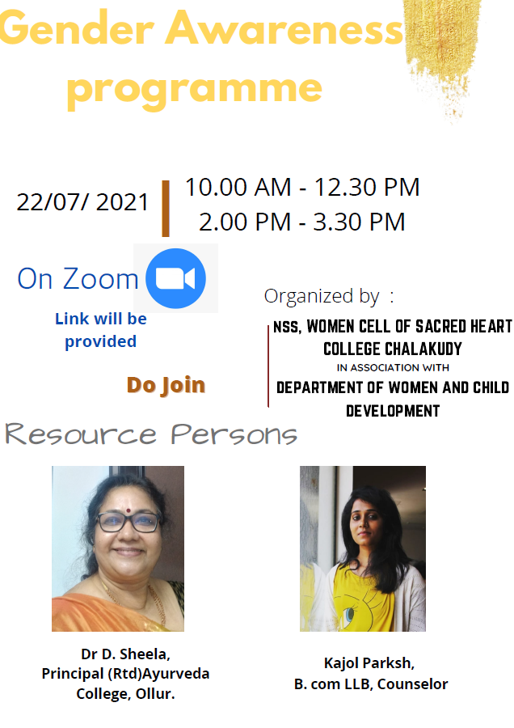
Women Cell and NSS of Sacred Heart College, Chalakudy in association with Department of Women and Child welfare devolepment, Kerala organized a One day “ Gender awareness program “ on 27-07-2021. Around 500 students participated the program. Dr. D. Sheela, Principal(Rtd) Ayurveda College, Ollur and Ms. Kajol Parksh, LLB, Counsellor were the resource persons
The link is provided below
‘https://drive.google.com/file/d/1INj-zaYiAtEB_ZO_Izm5jpvNnCAYlmuW/view?usp=sharing

