Report on International Women’s Day 2021

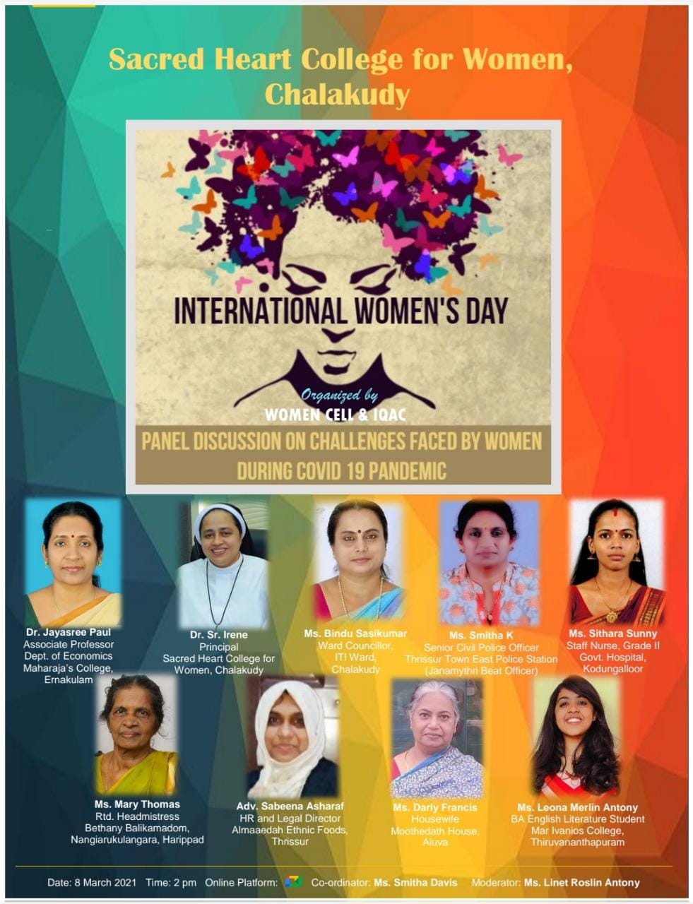
In Connection with International Women’s day on March 8, 2021, Women Cell, Sacred Heart College, Chalakudy organized a panel discussion on “Challenges faced by Women in Covid-19 pandemic situation”. 9 Women from various phases of life and different career paths shared their experiences. There were academicians, student, politician, police officer, staff nurse, entrepreneur, retired hands, and home makers who contributed for the fruitful discussion. Around 100 students from college also joined the program.

The link is given below

https://youtu.be/J4IKFkn9xYU

The Resource persons were:

Dr. Jayasree Paul, Associate professor, Dept. of Economics, Maharajas College, Ernakulam,
Dr. Sr. Irene, Principal, Sacred Heart College, Chalakudy.
Ms. Bindhu Sasikumar, Ward Counselor, ITI ward, Chalakudy.
Ms. Smitha K, Senior Civil police officer, Thrissur Town east police station.
Ms. Sithara Sunny, Staff Nurse, Grade II, Govt. hospital, Kodungallor.
Ms. Mary Thomas, Retd. Head Mistress, Betheny Balikamadam, Harippad.
Adv. Sabeena Ashraf, HR and legal director, Almaeedah Ethnic Foods, Thrissur.
Ms. Darly Francis, Housewife, Moothedath House, Aluva.
Ms. Leona Merlin Antony, BA English Literature student, Mar Ivanios College, Thiruvanathapuram.

