SPEED ESTIMATION AND DETECTION OF MOVING VEHICLES BASED ON PROBABILISTIC PRINCIPAL COMPONENT ANALYSIS AND NEW DIGITAL IMAGE PROCESSING APPROACH

BY DR. SR. MINI TV

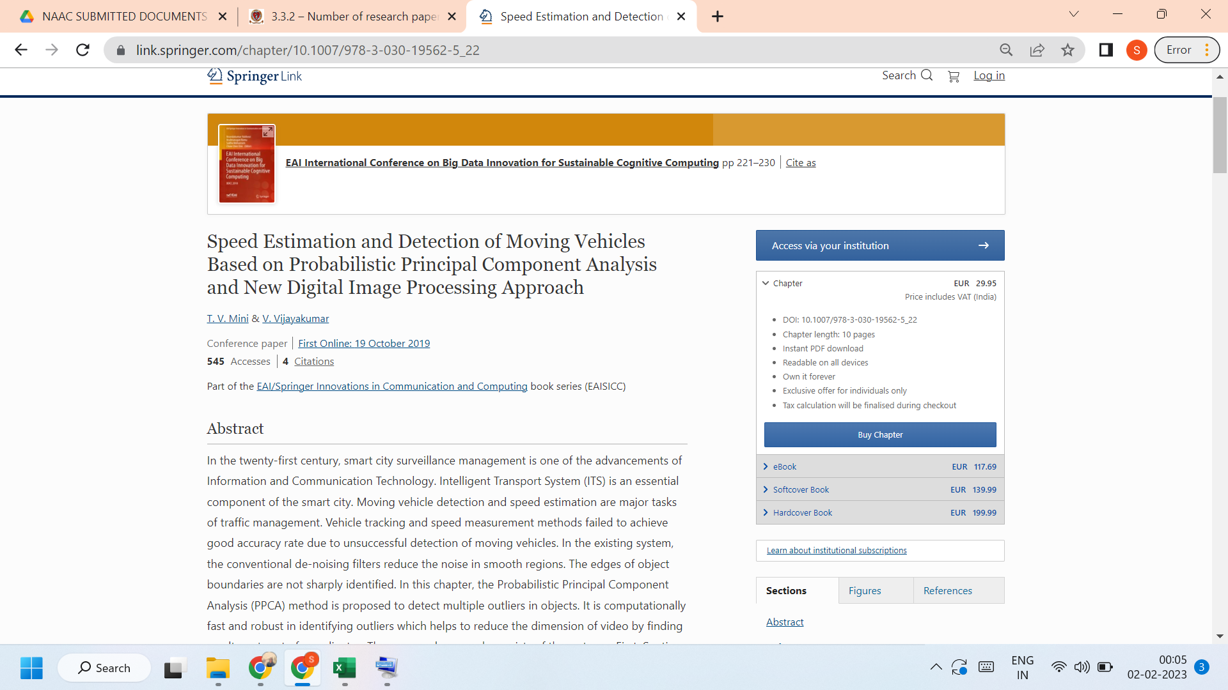

Link to the article:
https://link.springer.com/chapter/10.1007/978-3-030-19562-5_22

