PERSONS OF COLOUR AND THE TRAVEL: 12 YEARS A SLAVE AS THE TRAVEL OF BLACKS

BY MS. SANDRA JULIET JOSE

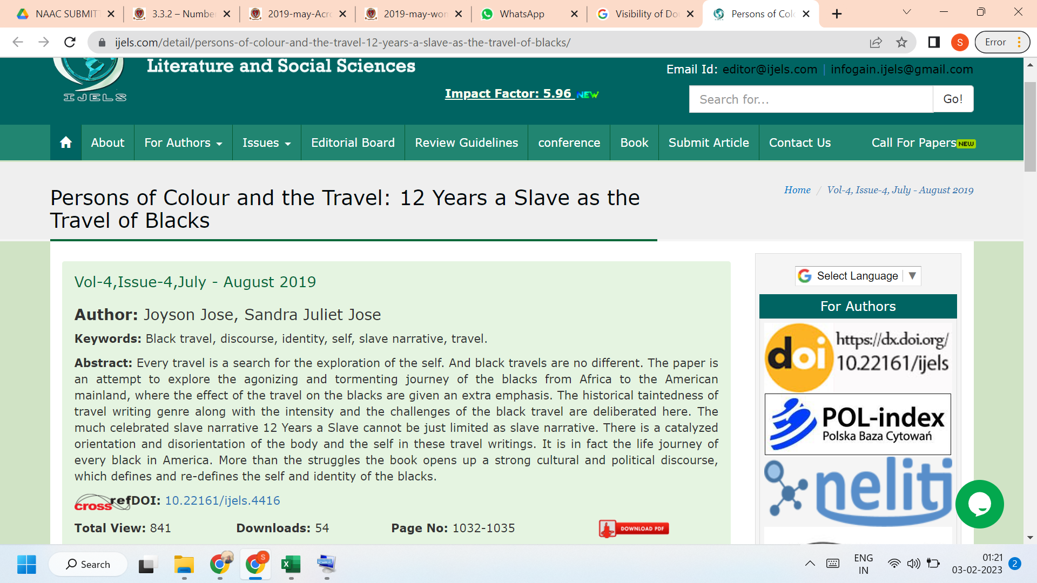

LINK TO THE ARTICLE:
https://ijels.com/detail/persons-of-colour-and-the-travel-12-years-a-slave-as-the-travel-of-blacks/

