EMBRACING CHANGE: FROM UNDERSTANDING TO ACTION
BY MS. NOBLE A PALIATH
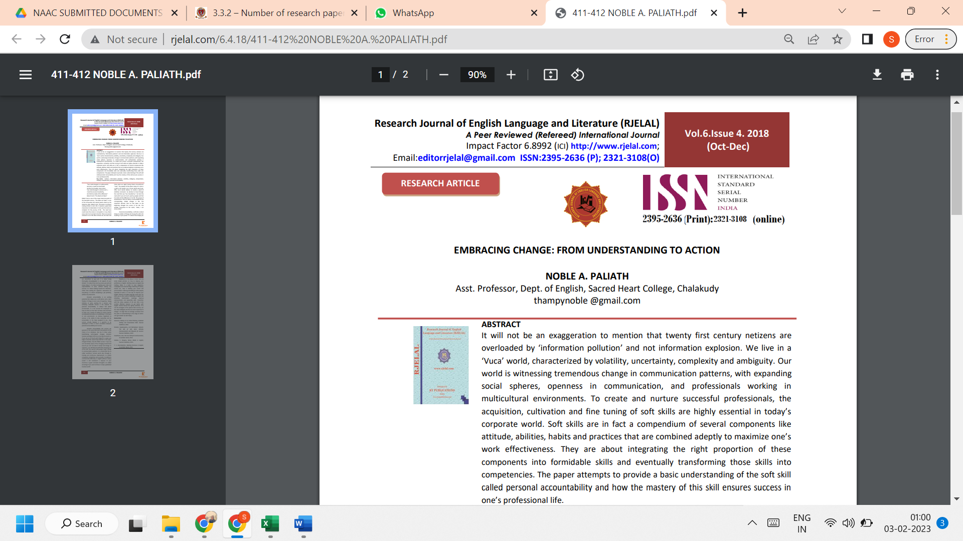

LINK TO THE ARTICLE:
http://www.rjelal.com/6.4.18/411-412%20NOBLE%20A.%20PALIATH.pdf

