WOMAN AS REFUGEE IN INSIDE OUT AND BACK AGAIN BY THANHHA LAI

BY DR. SR. A. PRINCY ANTO

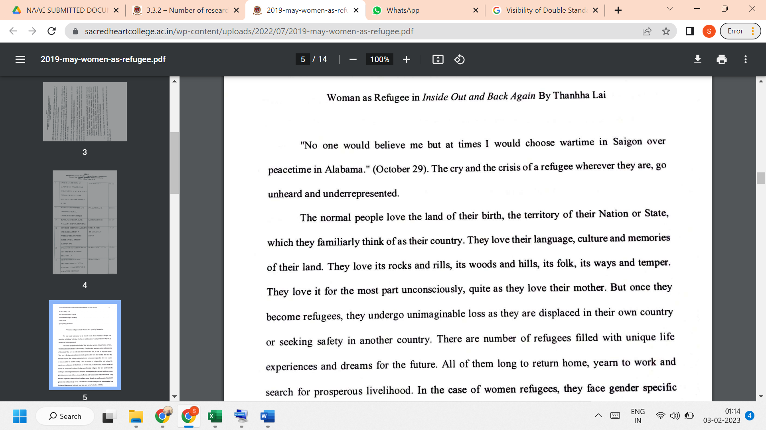

LINK TO THE ARTICLE:
PRINT JOURNAL

