SOCIO-ECONOMIC CONDITIONS AND HEALTH STATUS OF ELDERLY WOMEN IN RURAL AREA: A CASE STUDY OF PADIYO OR PANCHAYAT

BY NIJIL JACOBI

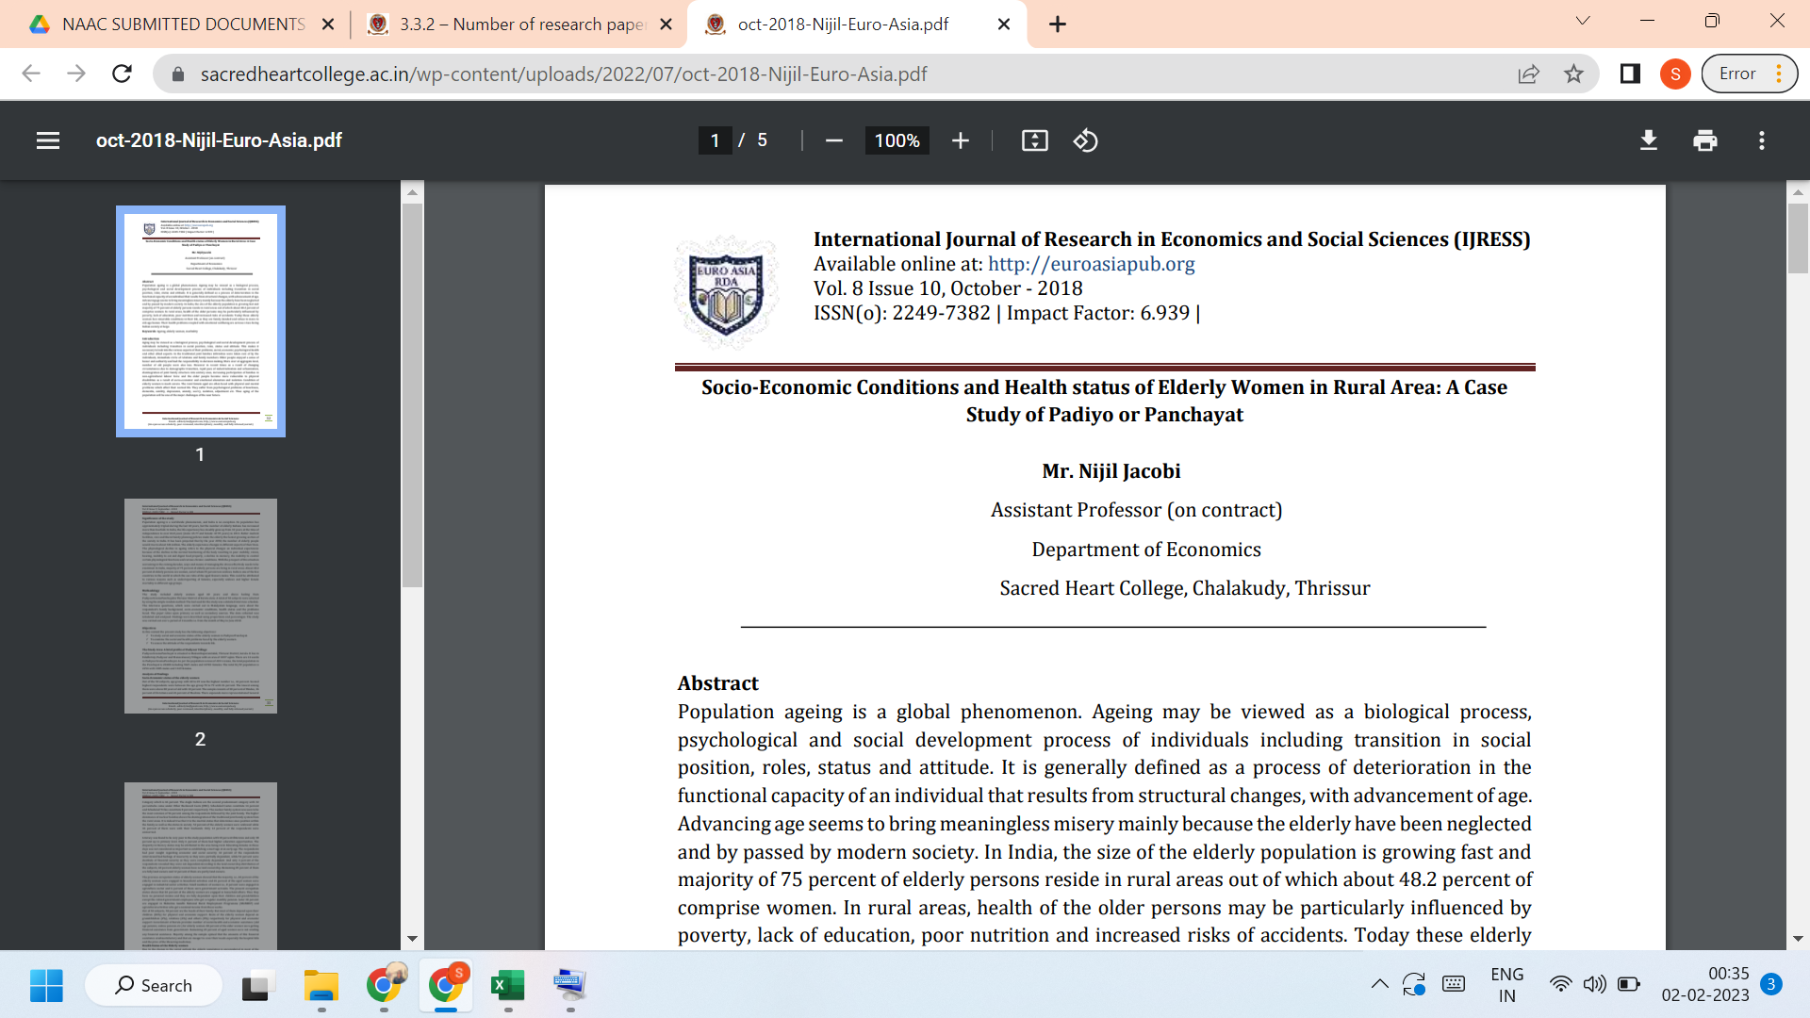
LINK TO THE ARTICLE:
https://euroasiapub.org/category/ijress/past-ijress/volume-8-issue-10-october-2018-current-ijress/page/3/?https%3A%2F%2Feuroasiapub_org%2Fcategory%2Fijress%2Fpast-ijress%2Fvolume-8-issue-10-october-2018-current-ijress%2F

