THE AGE OF DIGITAL TECHNOLOGY IN MUSIC INDUSTRY

BY DR. CHACKO JOSE P

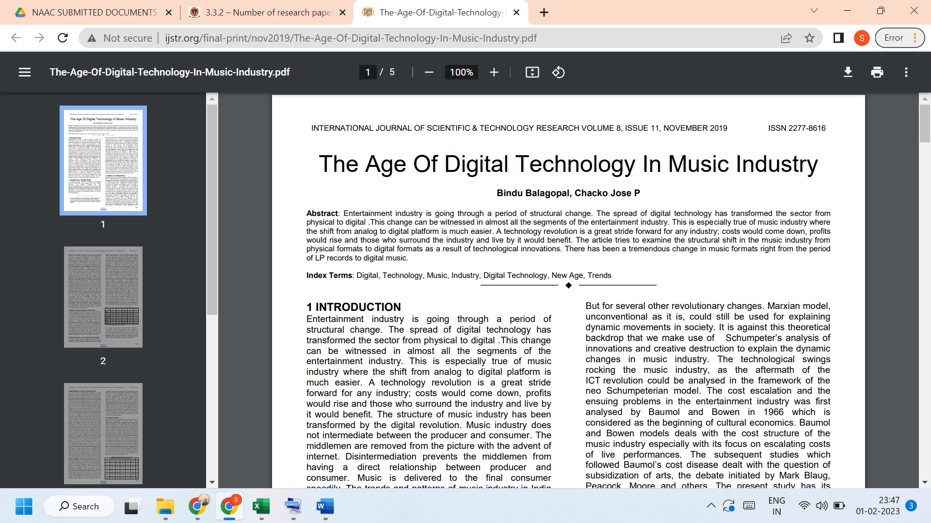

LINK TO THE ARTICLE:
http://www.ijstr.org/final-print/nov2019/The-Age-Of-Digital-Technology-In-Music-Industry.pdf

