NUMERICAL TECHNIQUES FOR UNSTEADY NONLINEAR BURGERS EQUATION BASED ON BACKWARD DIFFERENTIATION FORMULAS

BY DR. VIJITHA MUKUNDAN

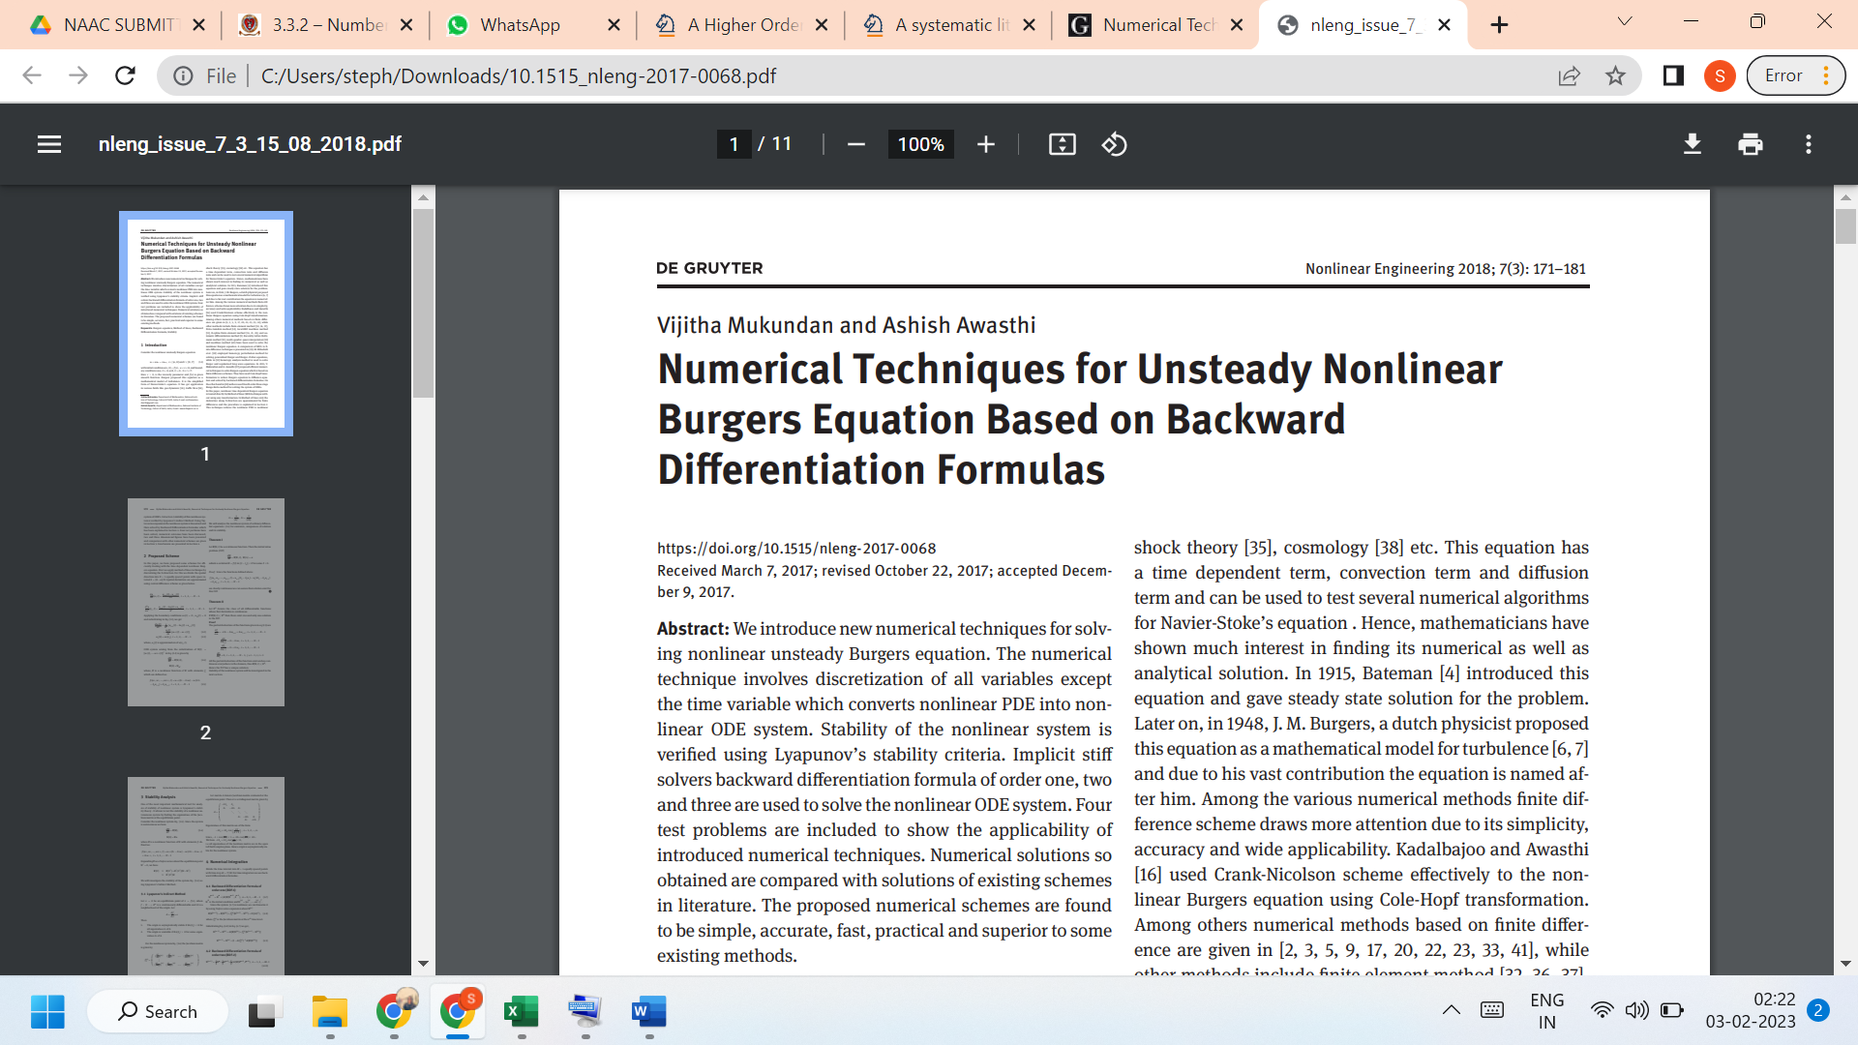

LINK TO THE ARTICLE:
https://www.degruyter.com/document/doi/10.1515/nleng-2017-0068/html

