A SYSTEMATIC LITERATURE REVIEW OF BURGERS’ EQUATION WITH RECENT ADVANCES

BY DR. VIJITHA MUKUNDAN

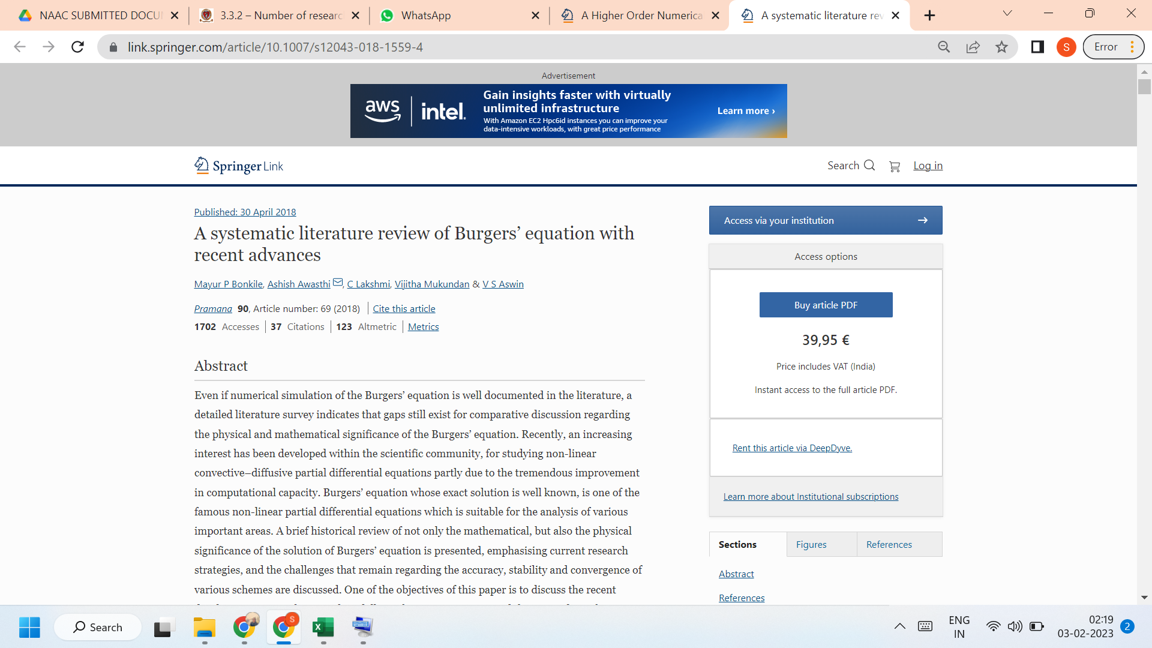

LINK TO THE ARTICLE:
https://link.springer.com/article/10.1007/s12043-018-1559-4

