EXPERIMENTAL AND THEORETICAL STUDIES ON THE BIFURCATED HYDROGEN BONDED NLO ACTIVE MATERIAL OF PURE AND CRYSTAL VIOLET DYE-DOPED L-ARGININIUM BIS DIHYDROGEN PHOSPHATE

BY DR. SR. REENA ITTYACHAN

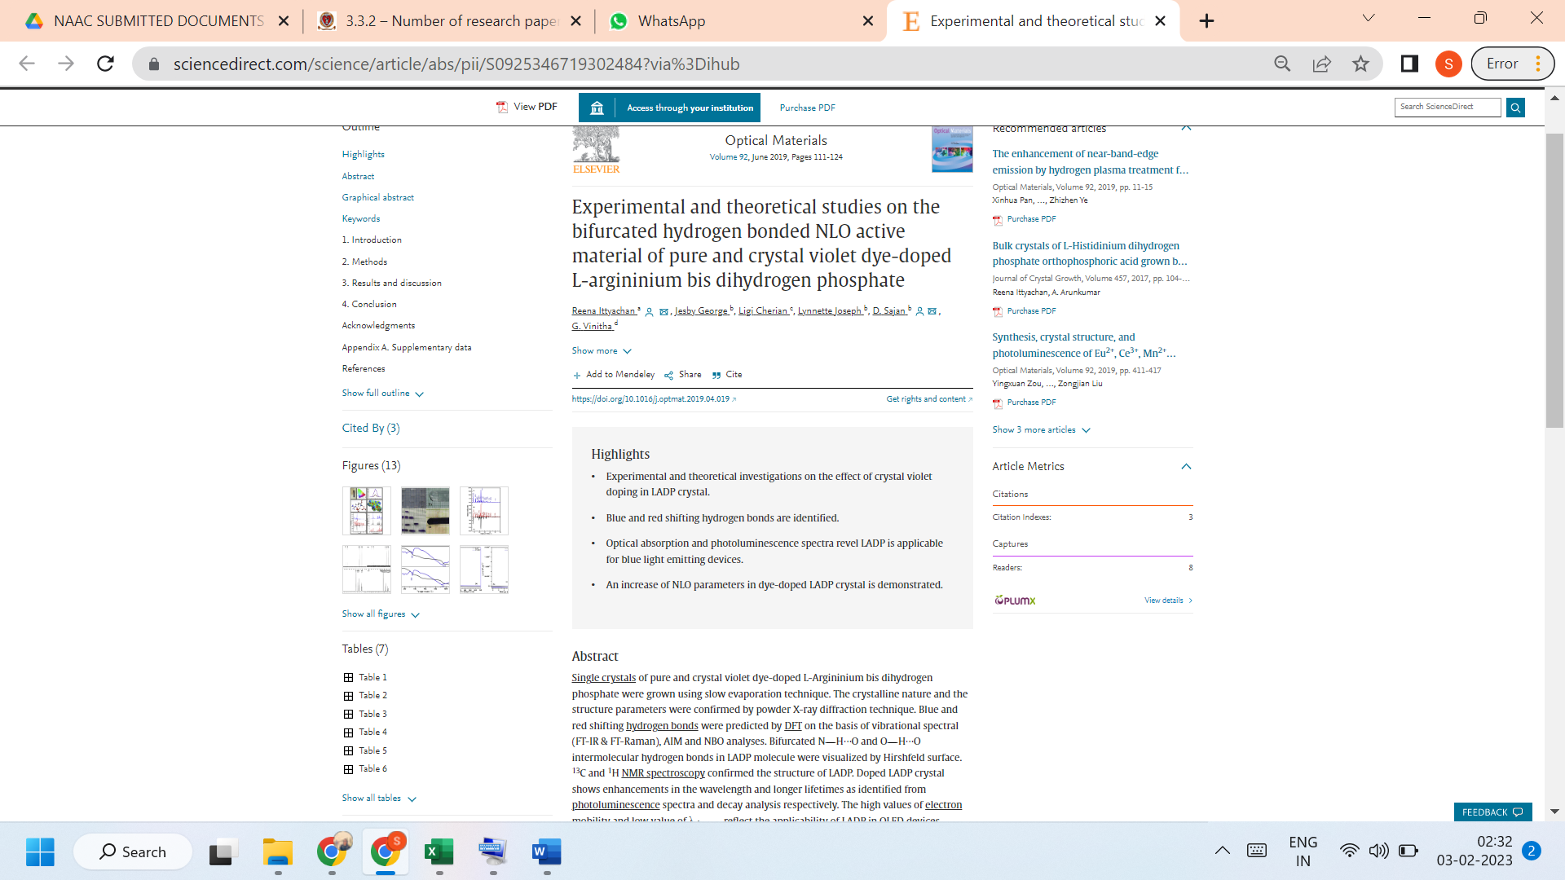

LINK TO THE ARTICLE:
https://www.sciencedirect.com/science/article/abs/pii/S0925346719302484?via%3Dihub

