A HIGHER ORDER NUMERICAL IMPLICIT METHOD FOR NON-LINEAR BURGERS’ EQUATION

BY DR. VIJITHA MUKUNDAN

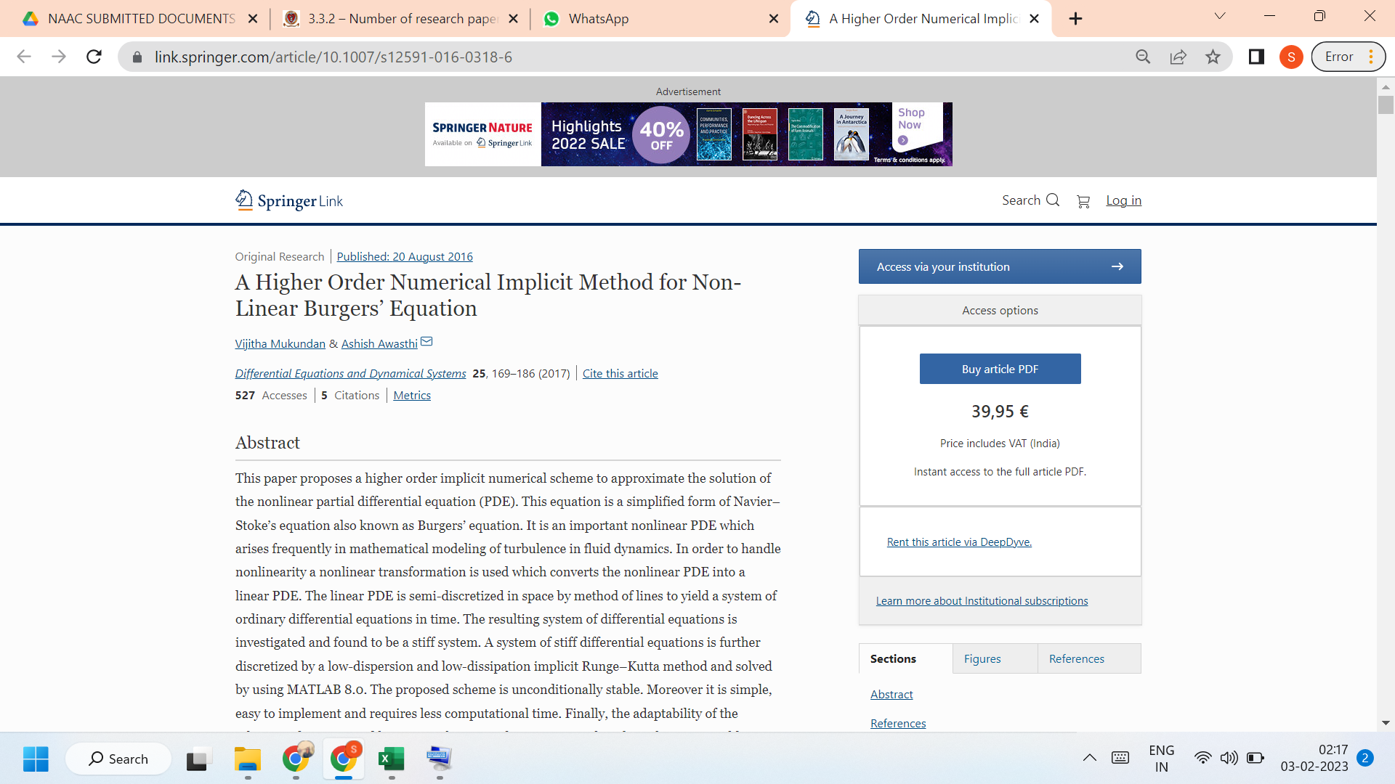

LINK TO THE ARTICLE:
https://link.springer.com/article/10.1007/s12591-016-0318-6

