GROWTH, Z-SCAN AND DENSITY FUNCTIONAL THEORETICAL STUDY FOR INVESTIGATING THE NONLINEAR OPTICAL PROPERTIES OF GUANIDINIUM L-GLUTAMATE FOR OPTICAL LIMITING APPLICATIONS

BY DR. SR. REENA ITTYACHAN

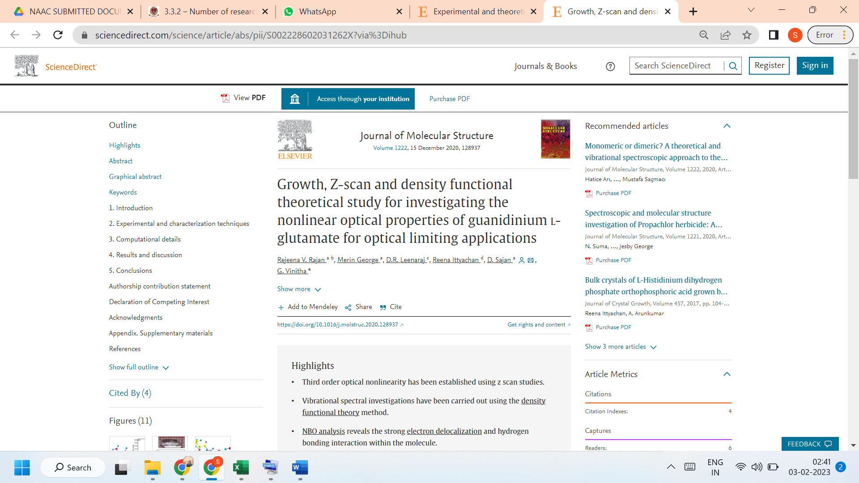

LINK TO THE ARTICLE:
https://www.sciencedirect.com/science/article/abs/pii/S002228602031262X?via%3Dihub

