UNSEXING AND SUSPENDING GENDER IN JEANETTE WINTERSON’S ORANGES ARE NOT THE ONLY FRUIT (1985)

BY MS. NOBLE A PALIATH

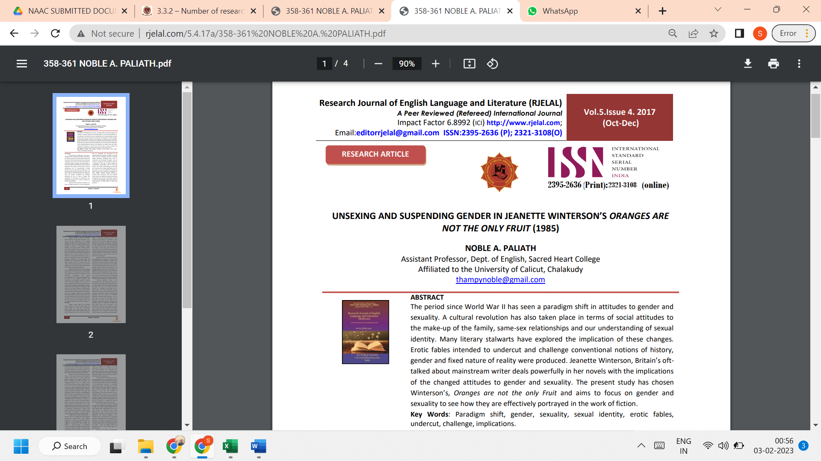

LINK TO THE ARTICLE:
http://www.rjelal.com/5.4.17a/358-361%20NOBLE%20A.%20PALIATH.pdf

