TRIBAL EMPLOYMENT THROUGH MAHATMA GANDHI NATIONAL RURAL EMPLOYMENT GUARANTEE ACT (MGNREGA) IN THE STATE OF KERALA

BY DR. CHACKO JOSE P

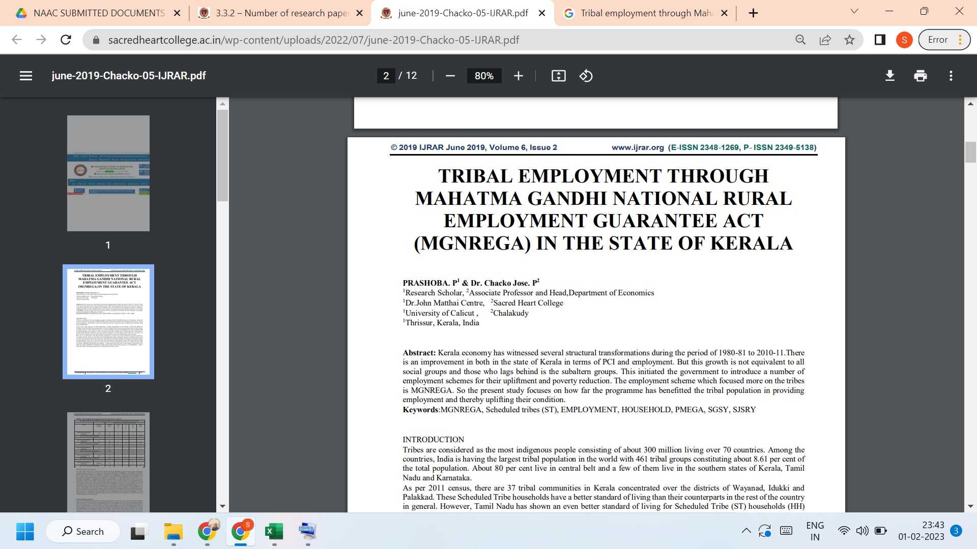

Link to the article:
https://www.ijrar.org/papers/IJRAR19K3739.pdf

