DEVELOPMENT OF AN EFFICIENT ASSOCIATION RULE CLASSIFIER WITH TEMPORAL CHARACTERISTICS AND HIERARCHICAL PARTITIONING

BY DR. SR. MINI T.V

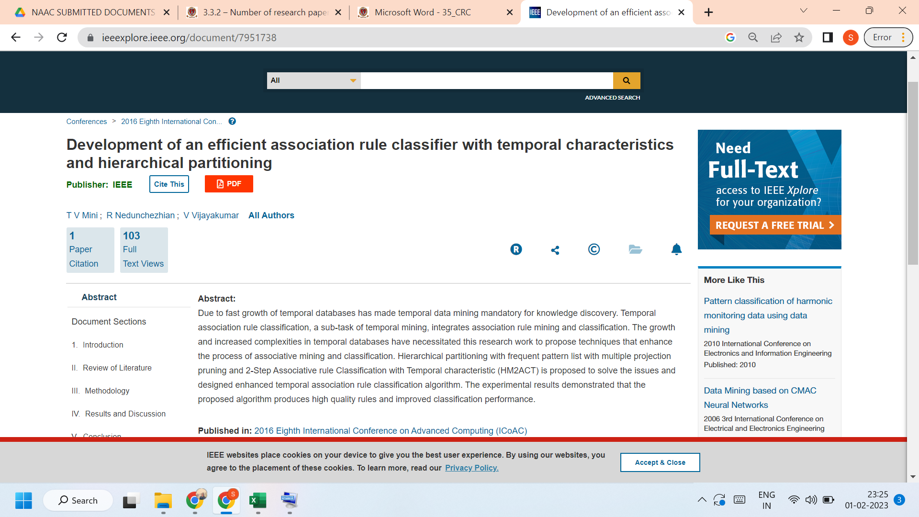
Link to the article:
https://ieeexplore.ieee.org/document/7951738

