LIVING LIFE TO THE FULLEST: TOWARDS AN UNDERSTANDING OF DISABLED CHILDREN'S CHILDHOOD STUDIES

BY MS. NOBLE A PALIATH
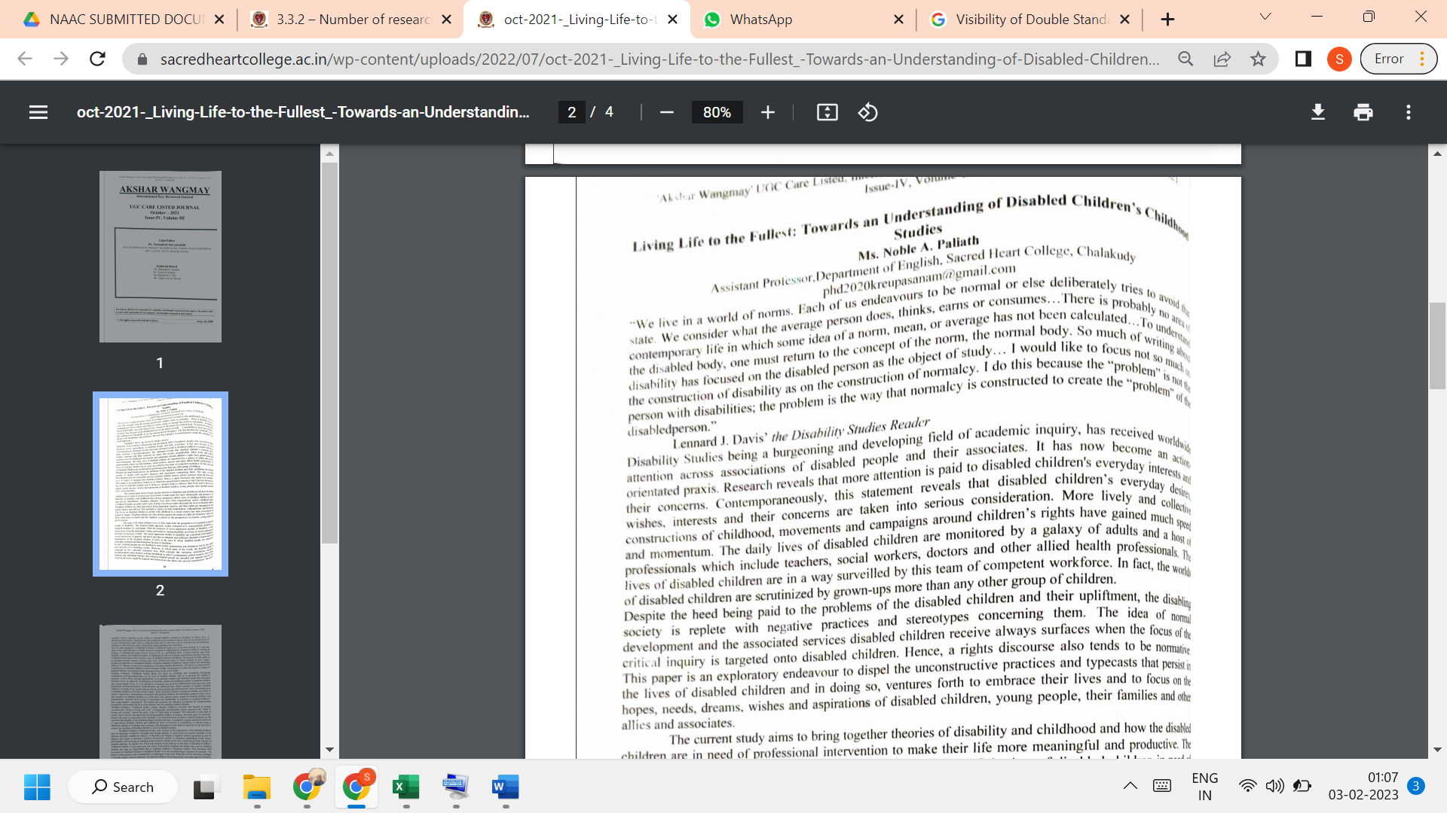

LINK TO THE ARTICLE:
PRINT JOURNAL

