SPECTROSCOPIC, DENSITY FUNCTIONAL THEORETICAL STUDY, MOLECULAR DOCKING, AND IN VITRO STUDIES BASED ON ANTICANCER ACTIVITY STUDIES AGAINST A₅₄₉ LUNG CANCER CELL LINE OF DIPHENYLHYDANTOIN ADSORBED ON AUNPS SURFACE

BY DR. SR. REENA ITTYACHAN

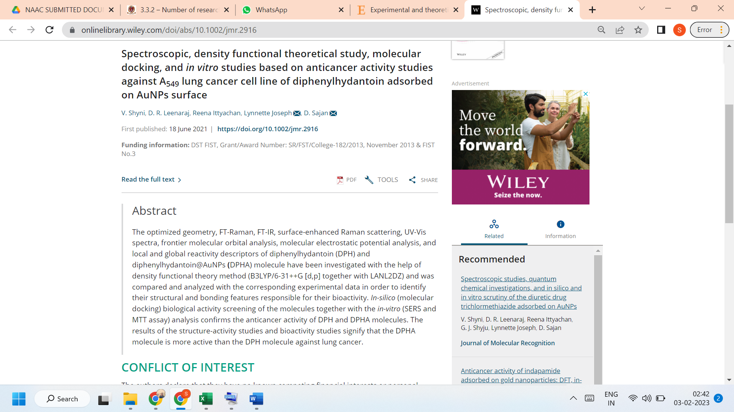

LINK TO THE ARTICLE:
https://onlinelibrary.wiley.com/doi/abs/10.1002/jmr.2916

