EXCAVATING SOURCES OF A GREAT FLOOD: TRAVANCORE FLOOD OF 1924

BY DR. MEENU JACOB

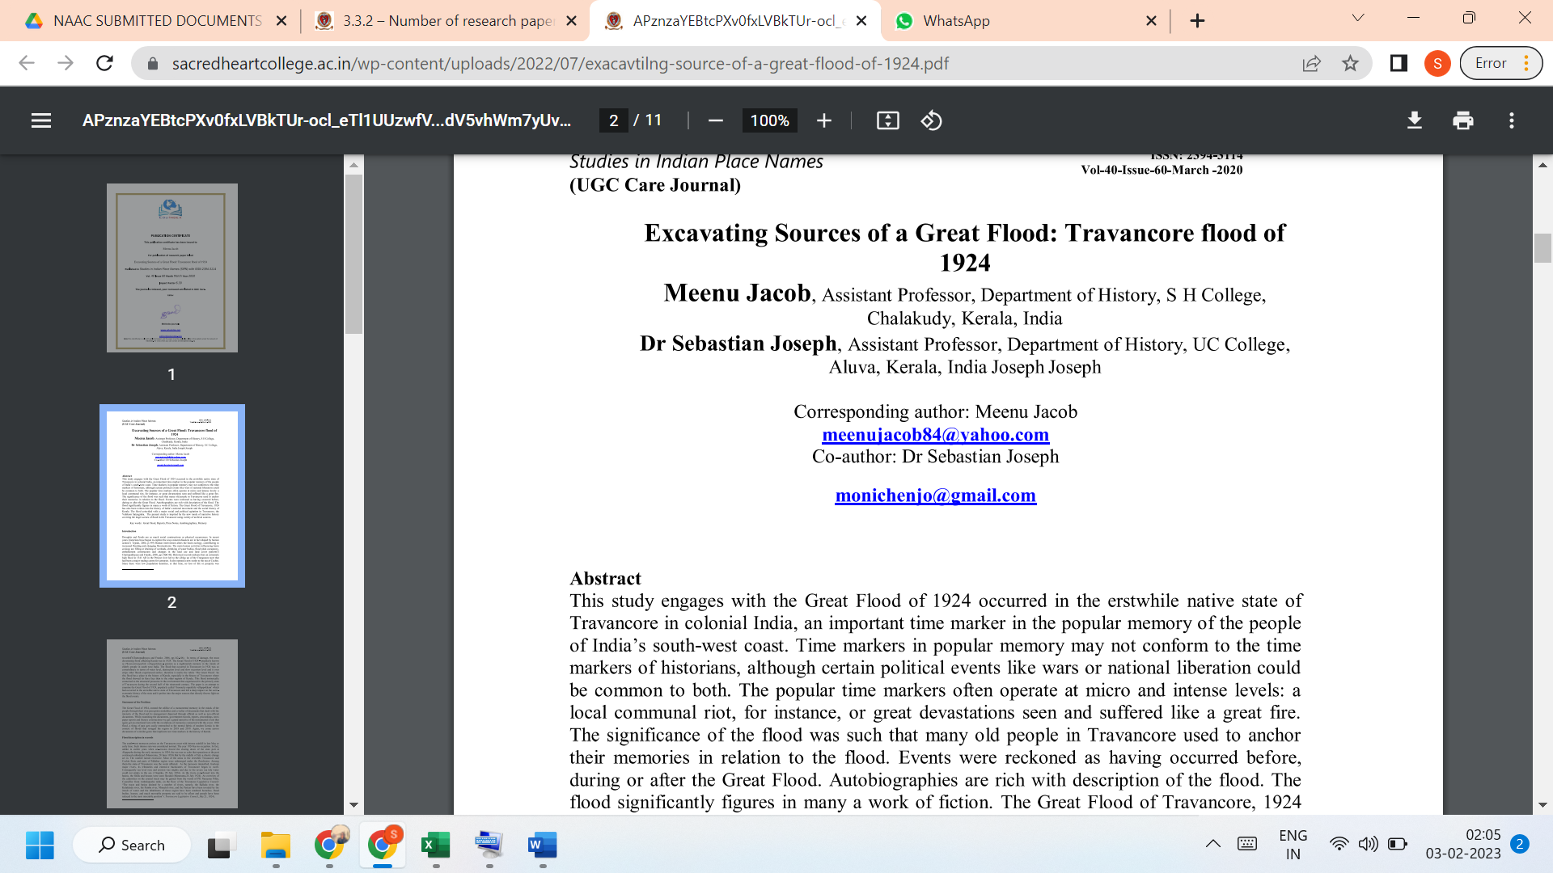

LINK TO THE ARTICLE:
https://tpnsindia.org/index.php/sipn/issue/archive

