MAPPING THE ART AND LANDSCAPE OF LITERARY RESEARCH

BY MS. NOBLE A PALIATH
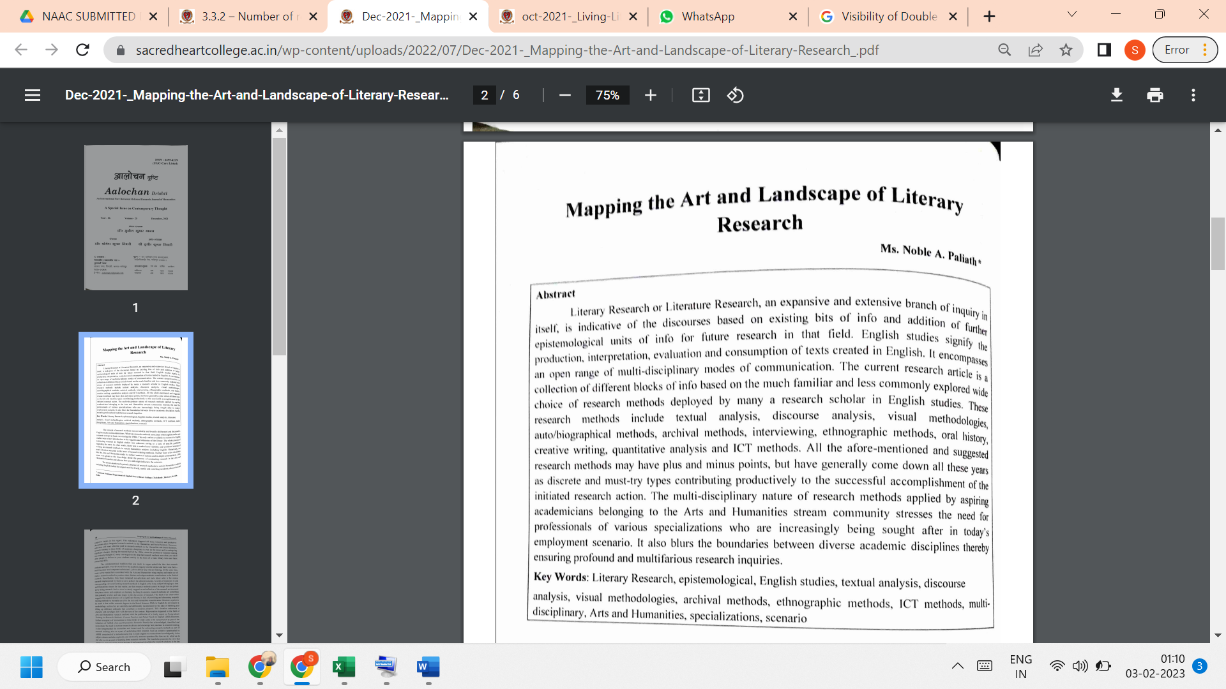

LINK TO THE ARTICLE:
PRINT JOURNAL

