IMAGINED’ FLOOD AS HISTORICAL NARRATIVE:GREAT FLOOD (1924) OF TRAVANCORE

BY DR. MEENU JACOB

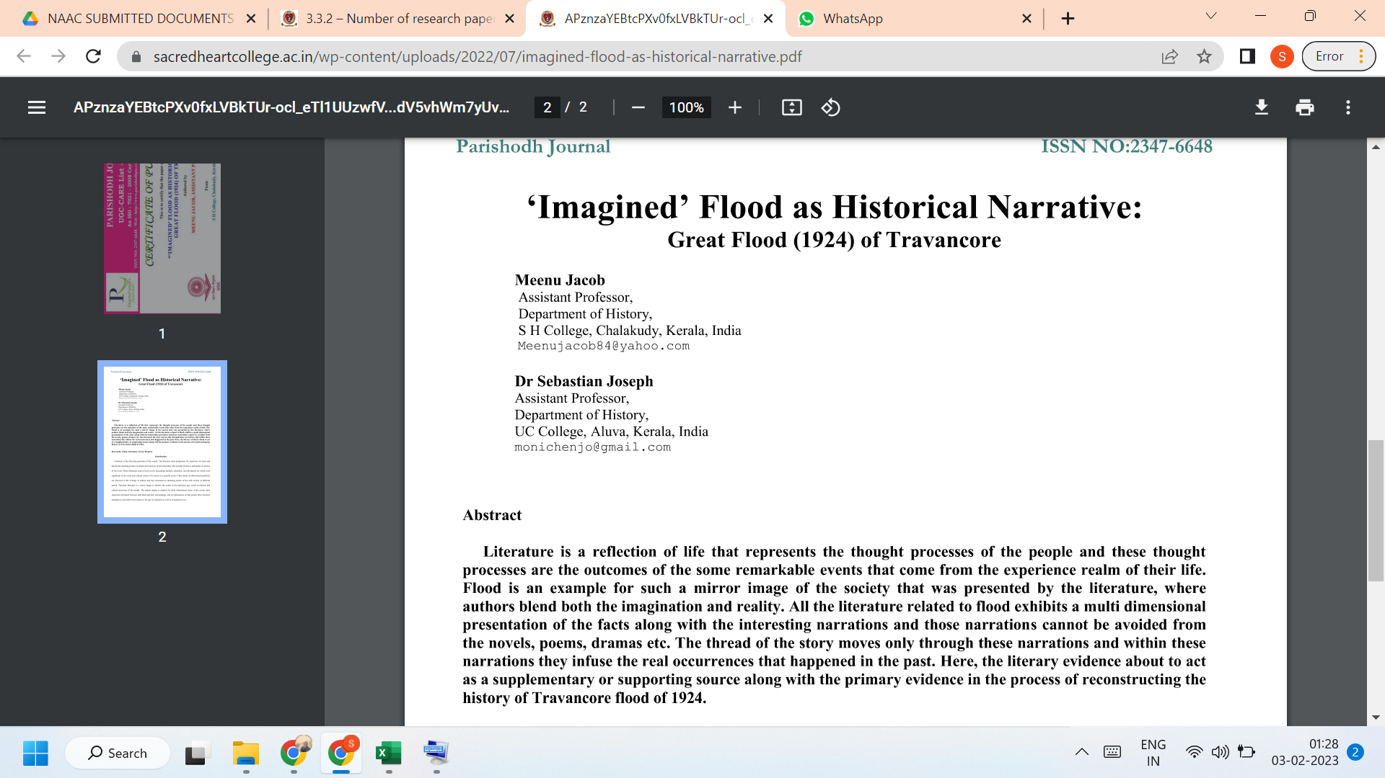

LINK TO THE ARTICLE:
PRINT JOURNAL

