ACCESSIBILITY OF MOBILE BANKING: A CASE STUDY OF VILLAGE IN KERALA

BY NIJIL JACOBI

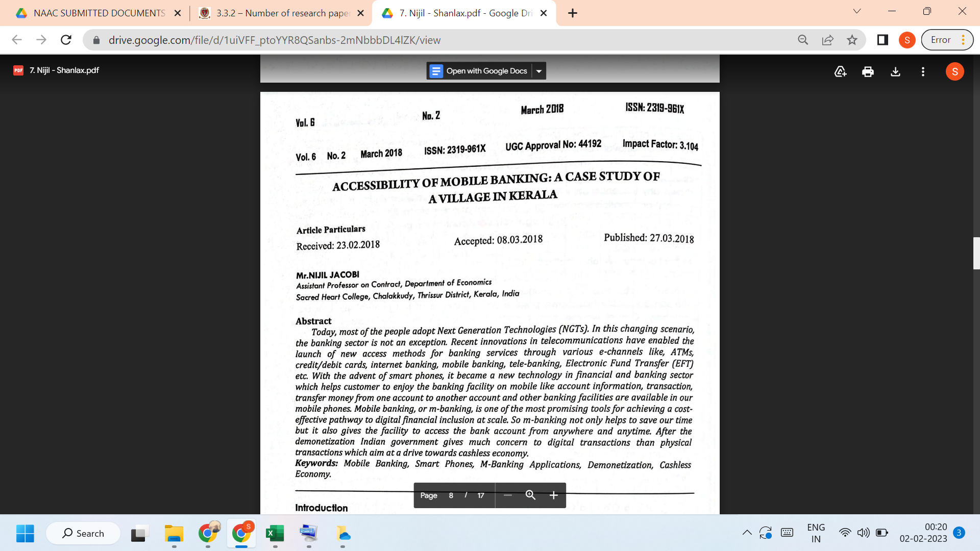
LINK TO THE ARTICLE:
PRINT JOURNAL

