ANTICANCER ACTIVITY OF INDAPAMIDE ADSORBED ON GOLD NANOPARTICLES: DFT, IN-SILICO, AND IN-VITRO ANALYSIS

BY DR. SR. REENA ITTYACHAN

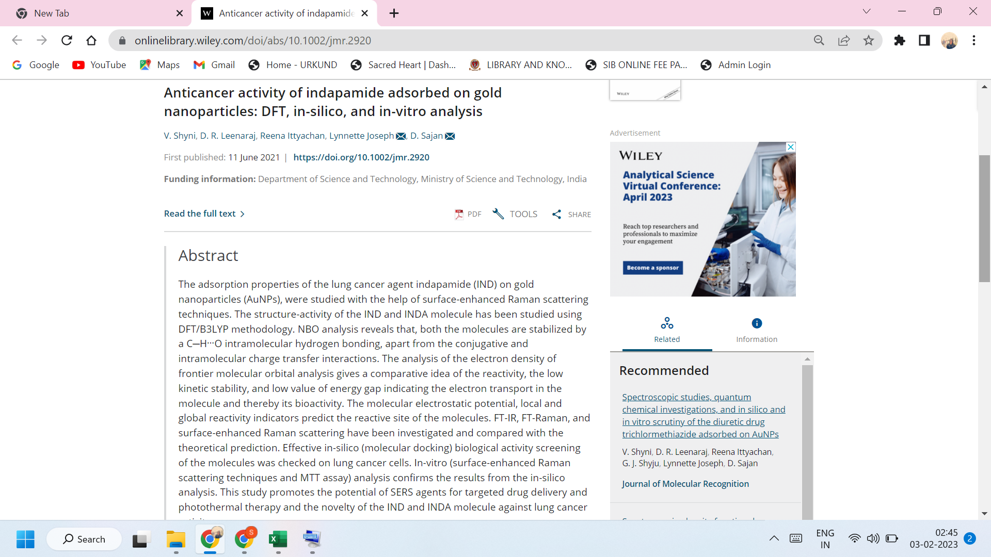

LINK TO THE ARTICLE:
https://onlinelibrary.wiley.com/doi/abs/10.1002/jmr.2916

