VISIBILITY OF DOUBLE STANDARDS: CONFLICT BETWEEN THE 'SOCIAL' AND THE 'PERSONAL' PERSPECTIVES IN NELLIE WONG'S "WHEN I WAS GROWING UP

BY MS. NOBLE A PALIATH
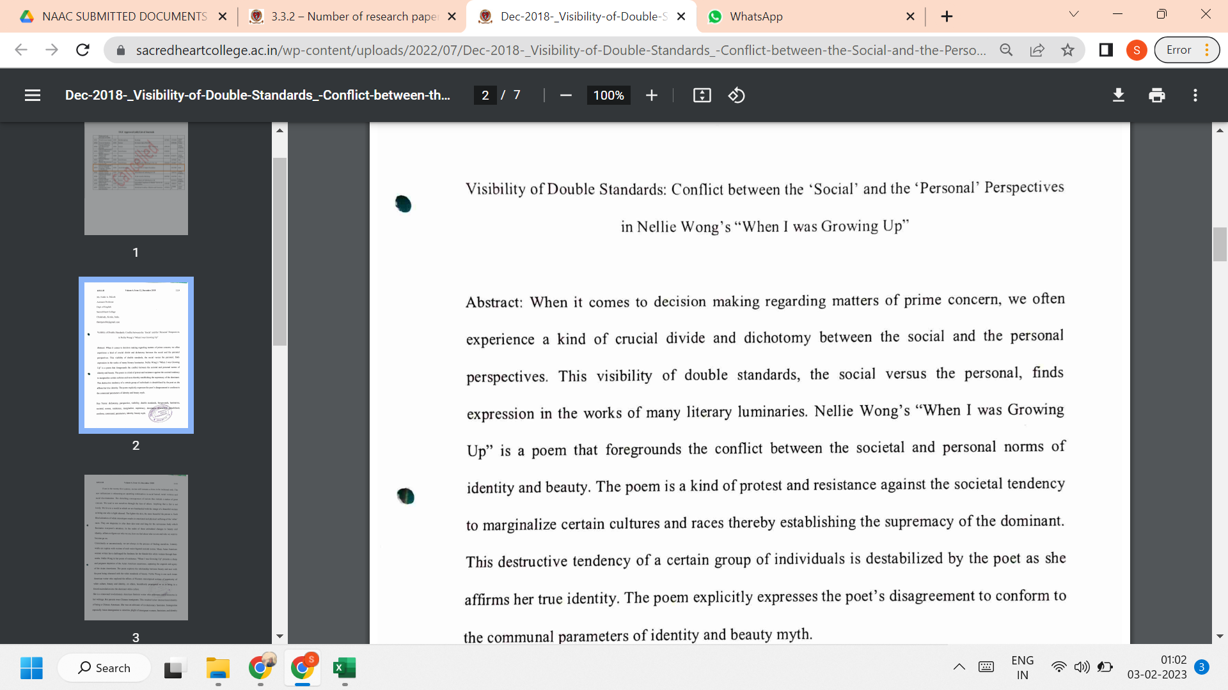

LINK TO THE ARTICLE:
PRINT JOURNAL

