ROLE OF KNOWLEDGE MANAGEMENT IN THE TRANSFORMATION OF INDIA INTO A KNOWLEDGE ECONOMY

BY DR. CHACKO JOSE P

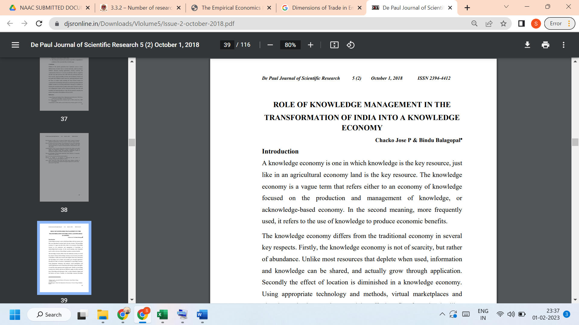

Link to the article:
https://djsronline.in/Downloads/Vlolume5/Issue-2-october-2018.pdf

