EMPOWERING WOMEN THROUGH ENTREPRENEURSHIP DEVELOPMENT IN INDIA

BY NIJIL JACOBI

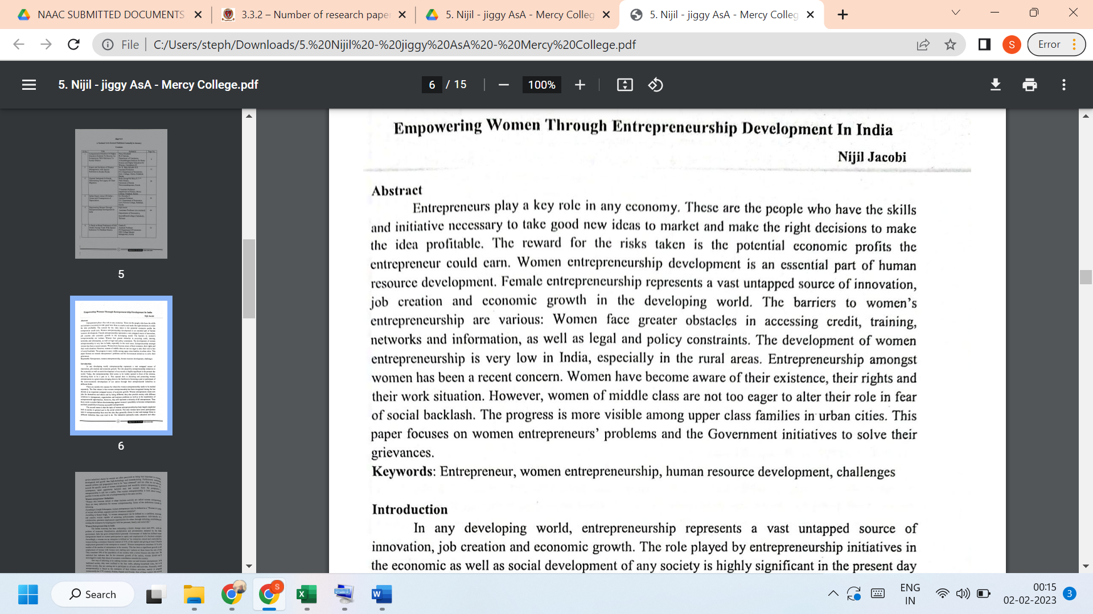
LINK TO THE ARTICLE:
PRINT JOURNAL

