NUMERICAL TREATMENT OF THE MODIFIED BURGERS’ EQUATION VIA BACKWARD DIFFERENTIATION FORMULAS OF ORDERS TWO AND THREE

BY DR. VIJITHA MUKUNDAN

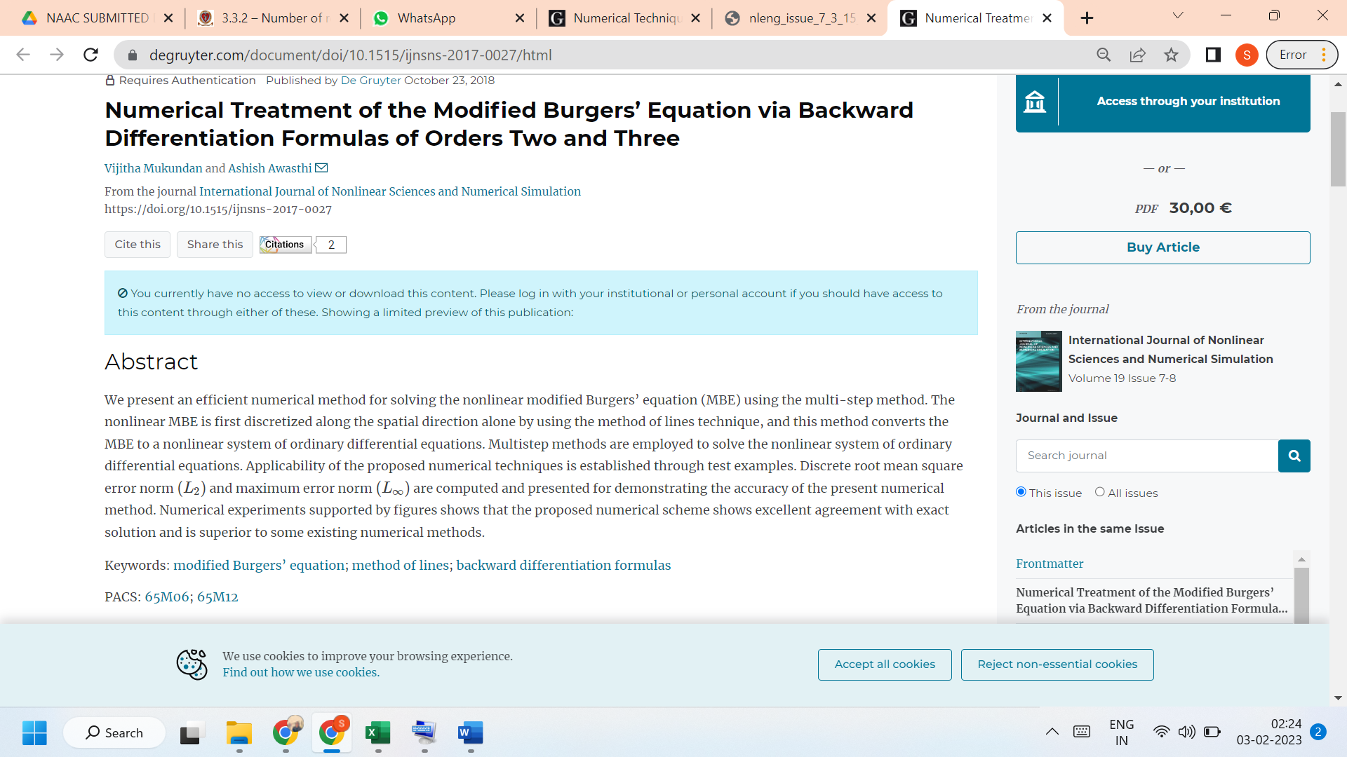

LINK TO THE ARTICLE:
https://www.degruyter.com/document/doi/10.1515/ijnsns-2017-0027/html

