ECOCINECRITICISM AND CULTURAL CONTEXTUALIZING: A STUDY OF THE ADAPTATION OF SHAKESPEARE’S OTHELLO INTO A MALAYALAM MOVIE KALIYATTAM

BY MS. SANDRA JULIET JOSE

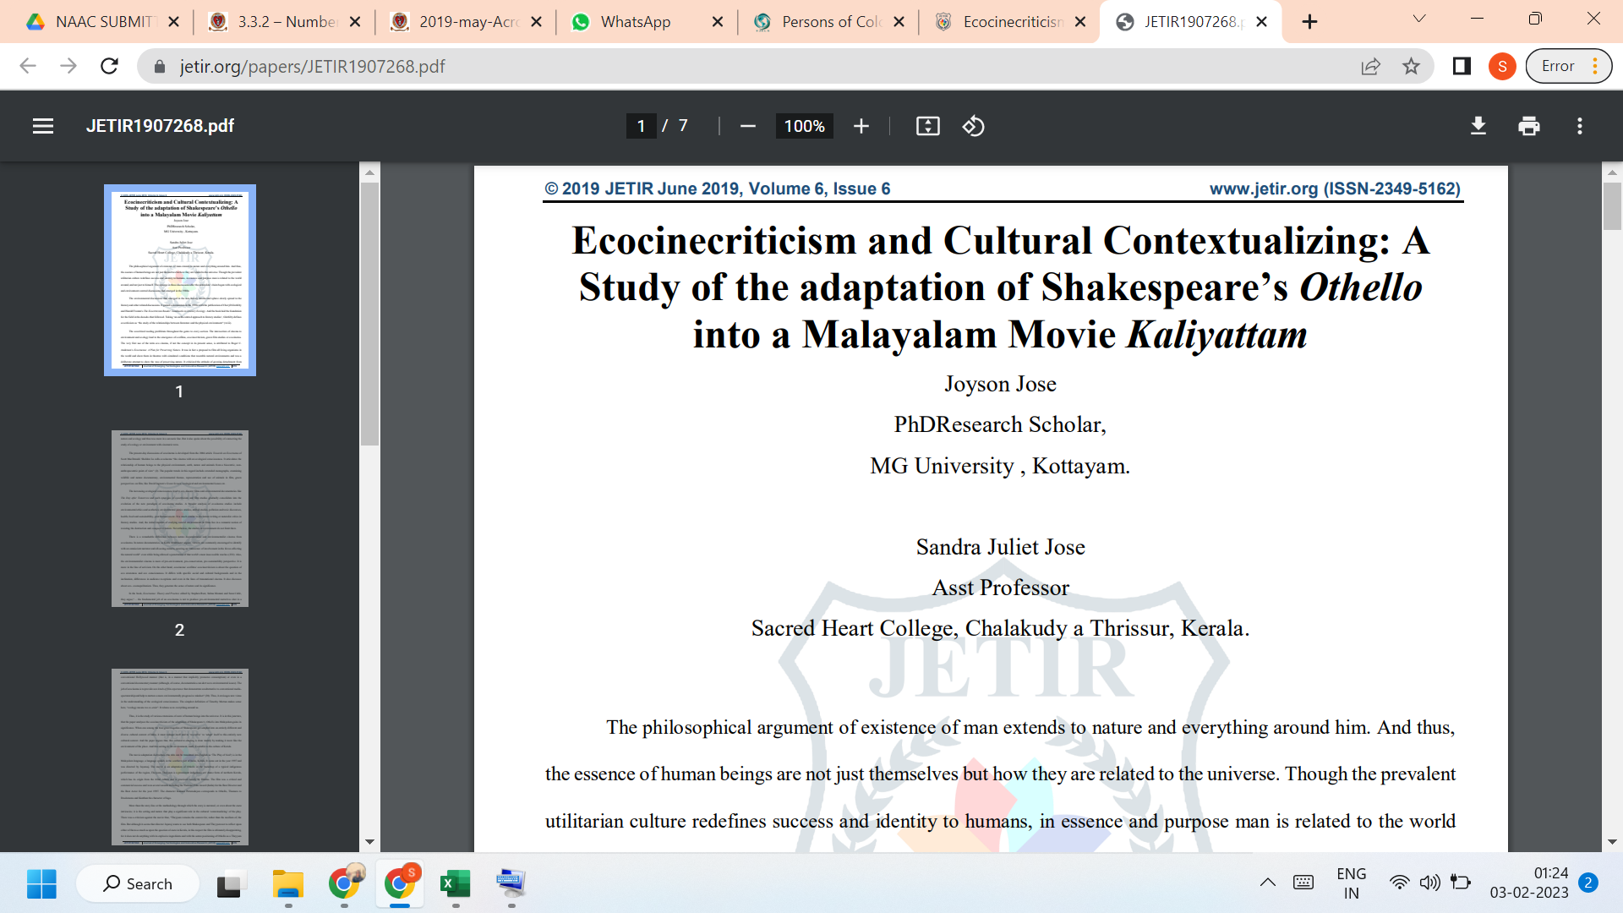

LINK TO THE ARTICLE:
https://www.jetir.org/papers/JETIR1907268.pdf

