A GLEAM OF LIGHT ON ASSOCIATION RULE MINING AND REDUCTION TECHNIQUES
BY DR. SR. MINI T.V
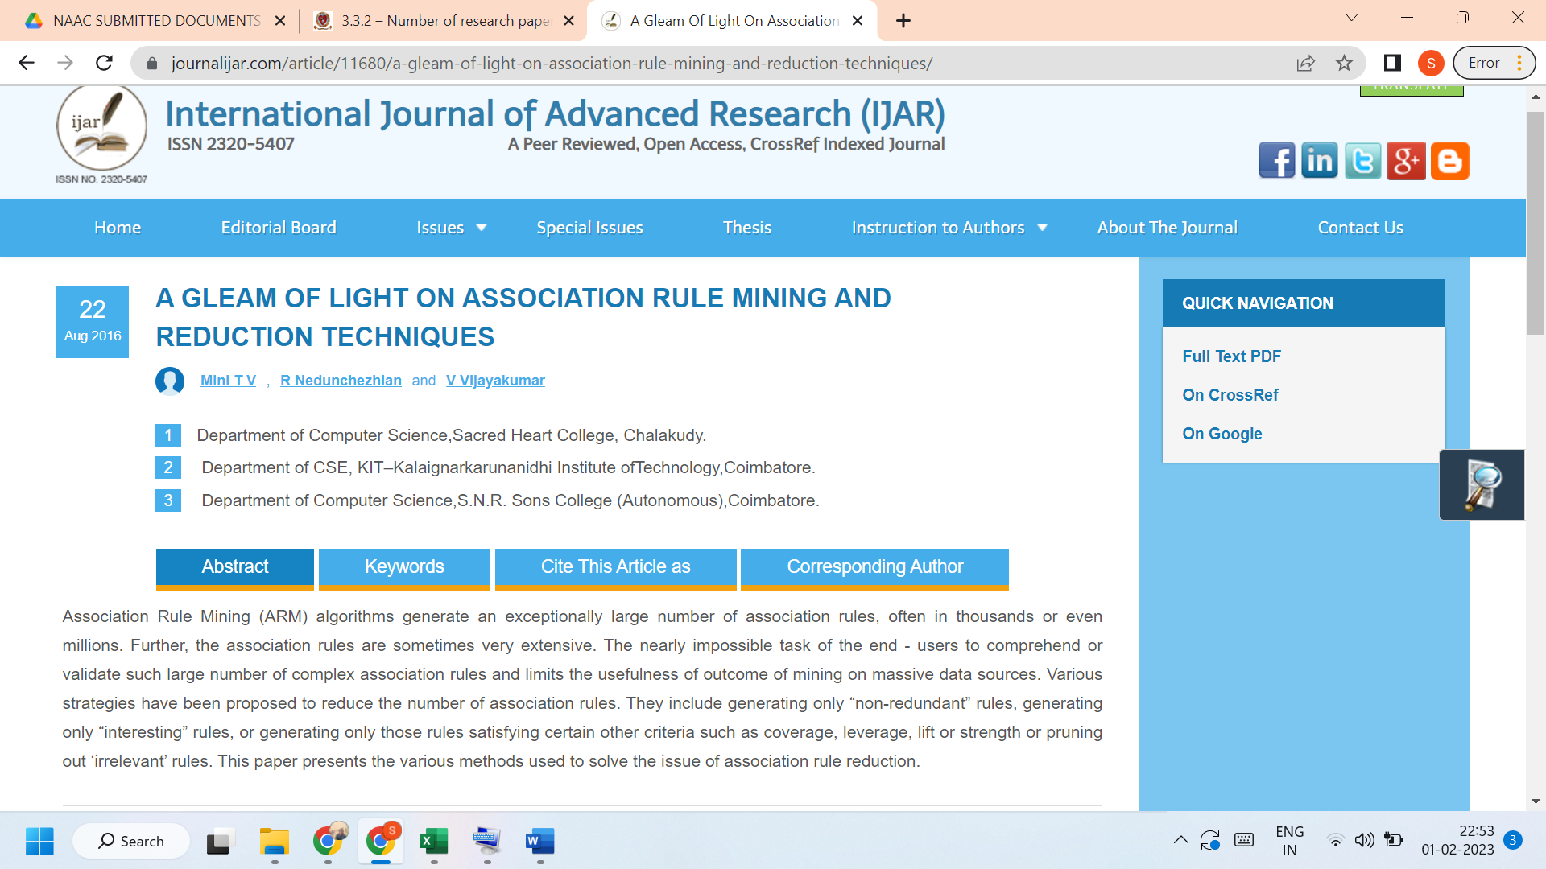

Link to the article:

https://www.journalijar.com/article/11680/a-gleam-of-light-on-association-rule-mining-and-reduction-techniques/

