ENVIRONMENTAL DEGRADATION AND MARKET FAILURES -

ROLE OF ENVIRONMENT EDUCATION FOR SUSTAINABLE DEVELOPMENT

BY DR. CHACKO JOSE P

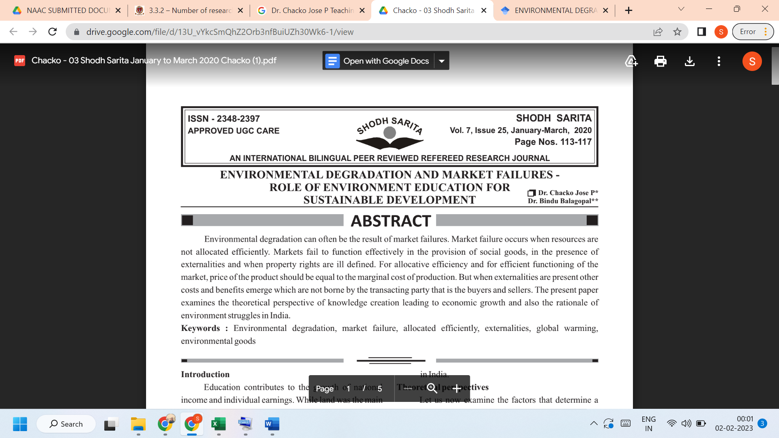
Link to the article:
https://drive.google.com/file/d/13U_vYkcSmQhZ2Orb3nfBuiUZh30Wk6-1/view

