FDI INFLOWS IN INDIA’S HOTEL AND TOURISM INDUSTRY: CONCEPTS AND TRENDS

BY NIJIL JACOBI

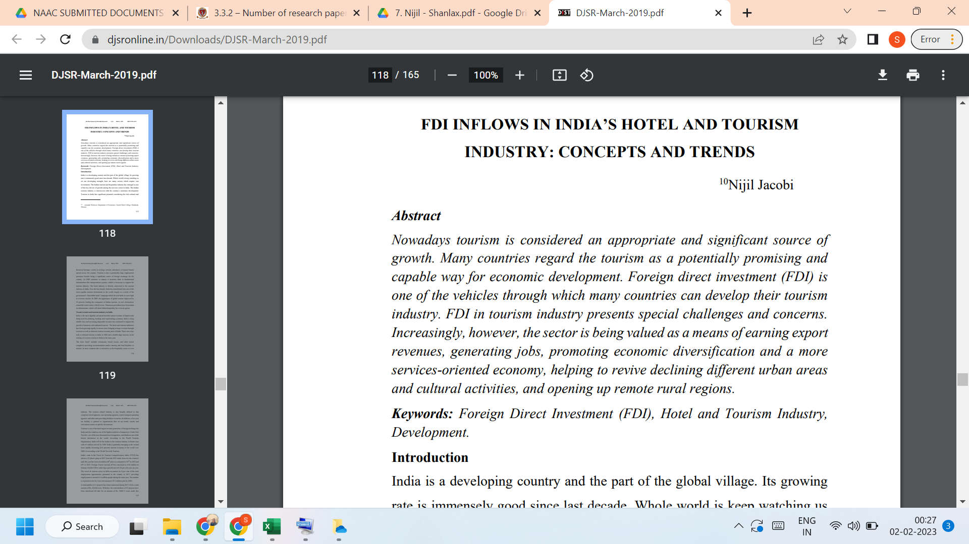
LINK TO THE ARTICLE:
https://djsronline.in/Downloads/DJSR-March-2019.pdf

