BULK CRYSTALS OF L-HISTIDINIUMDIHYDROGENPHOSPHATEORTHOPHOSPHORIC ACID GROWNBYSANKARANARAYANAN–RAMASAMYMETHOD

BY DR. SR. REENA ITTYACHAN

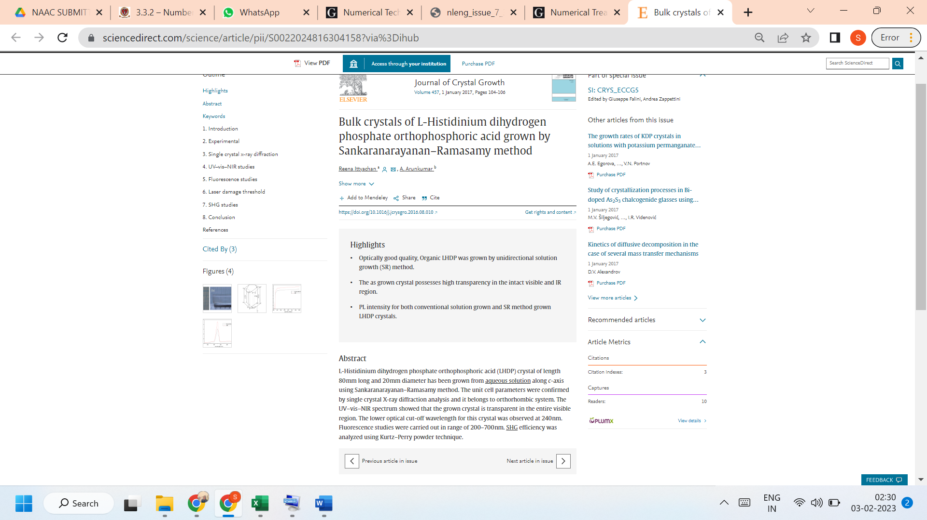

LINK TO THE ARTICLE:
https://www.sciencedirect.com/science/article/pii/S0022024816304158?via%3Dihub

