ACROSS LIMINALITY TO A GRAND NARRATIVE-THE HISTORIC EXPEDITION OF WOMEN WITH REGARD TO CHITHRA DIVAKARUNI'S QUEEN OF DREAMS

BY MS. DARLY MATHEW

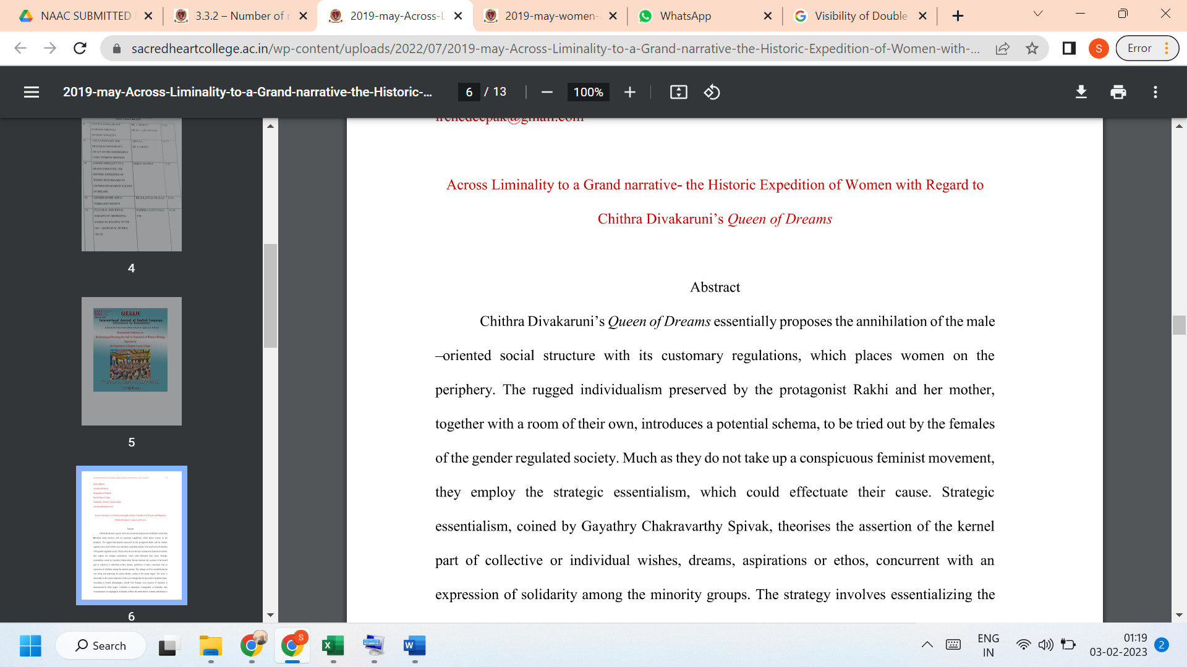

LINK TO THE ARTICLE:
PRINT JOURNAL

