MULTISTEP METHODS FOR THE NUMERICAL SIMULATION OF TWO-DIMENSIONAL BURGERS’ EQUATION

BY DR. VIJITHA MUKUNDAN

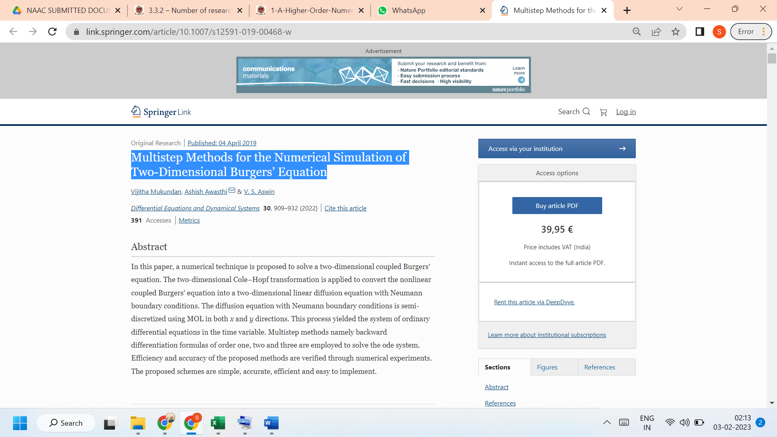

LINK TO THE ARTICLE:
https://link.springer.com/article/10.1007/s12591-019-00468-w

