IMPACT OF AGRICULTURAL EXTENSION PROGRAMMES OF KRISHIBHAVAN IN KERALA: CASE OF AGRICULTURAL FARMERS IN VELLAMGALLUR PANCHAYAT

BY NIJIL JACOBI

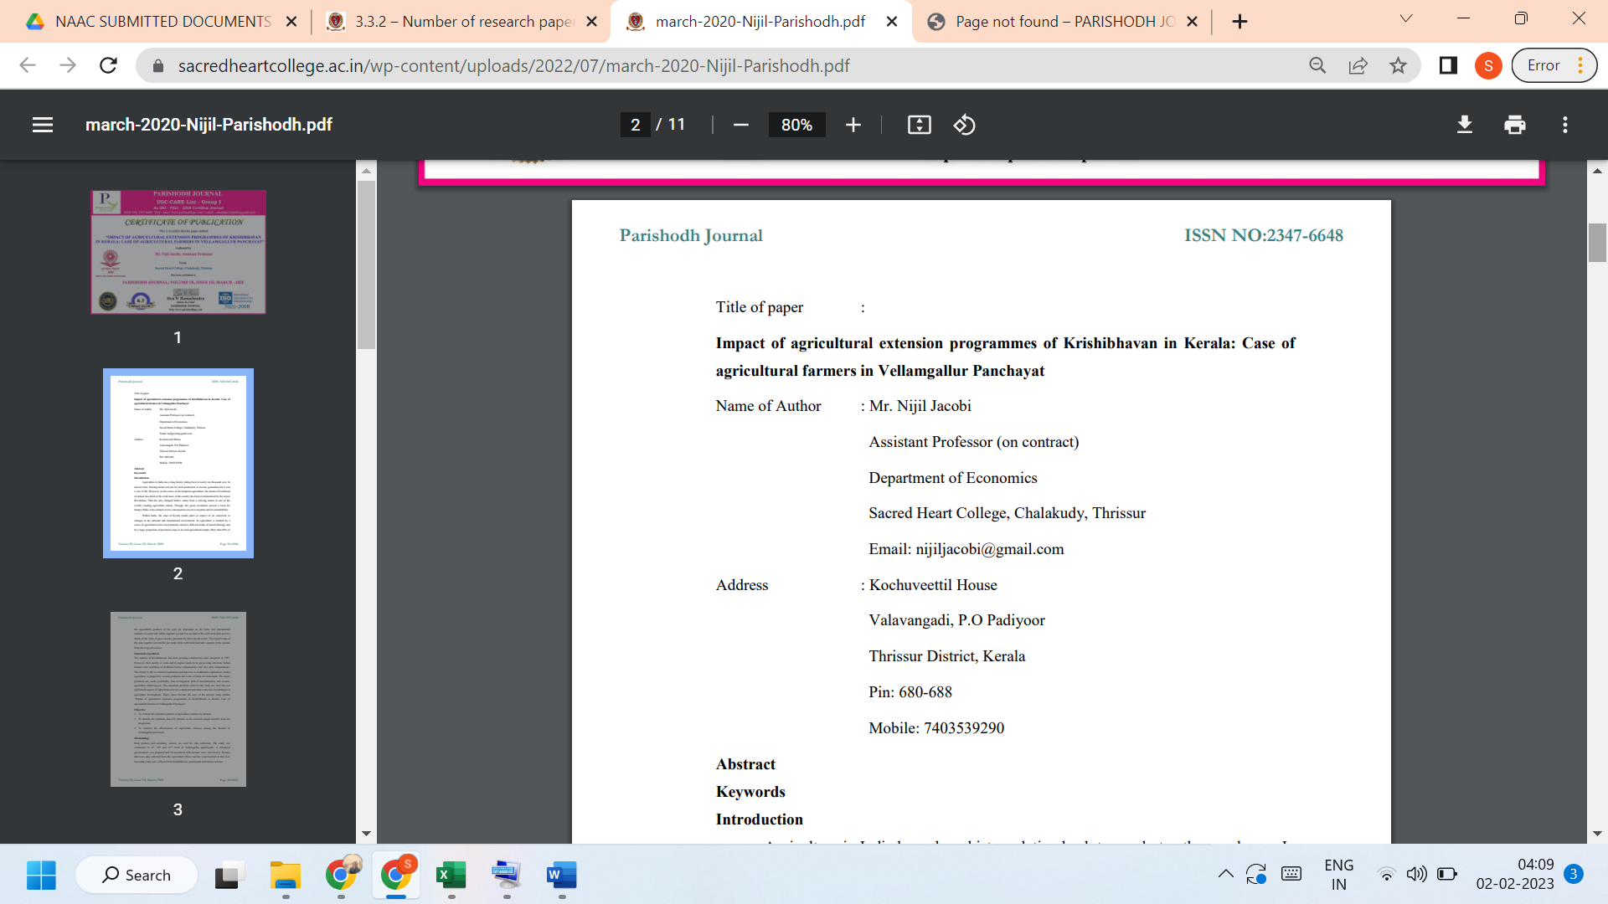
LINK TO THE ARTICLE:
https://parishodhpu.com/index.php/archeives/

