A NOVEL FRAMEWORK FOR MINING SUSPICIOUS ACTIVITIES IN SURVEILLANCE VIDEOS
BY DR. SR. MINI T.V

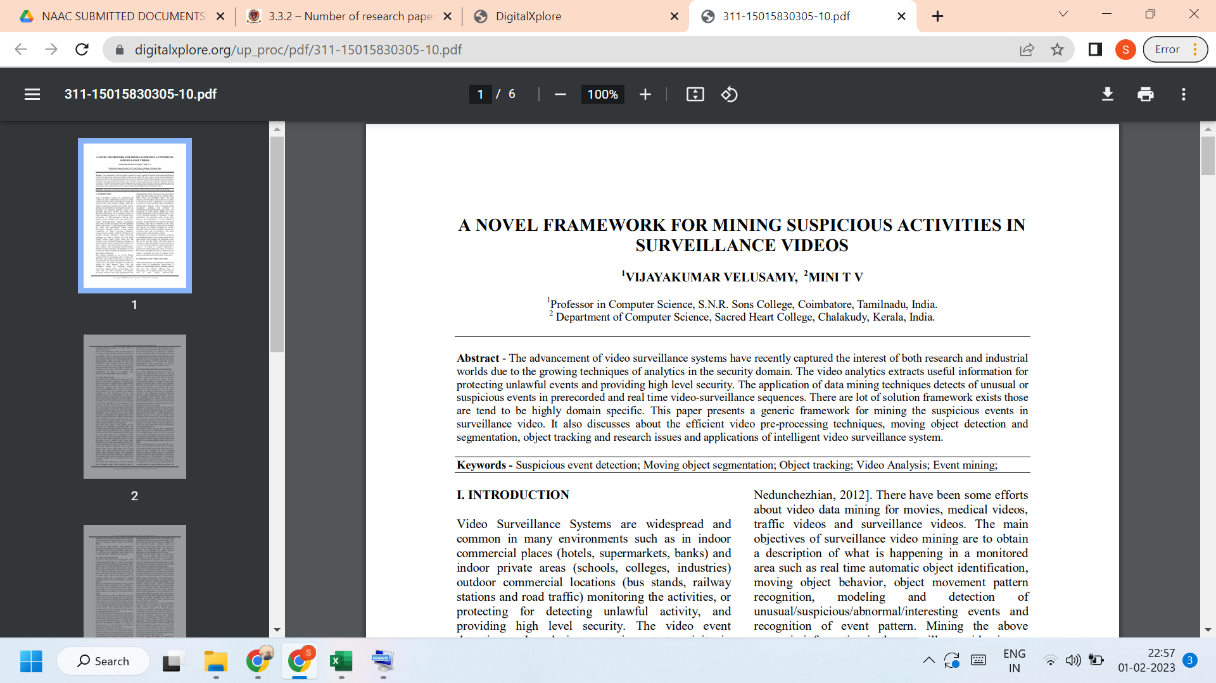
Link to the article:
https://www.digitalxplore.org/up_proc/pdf/311-15015830305-10.pdf

