SLOWING INDIAN ECONOMY: AN OVERVIEW OF CURRENT SCENARIO

BY NIJIL JACOBI

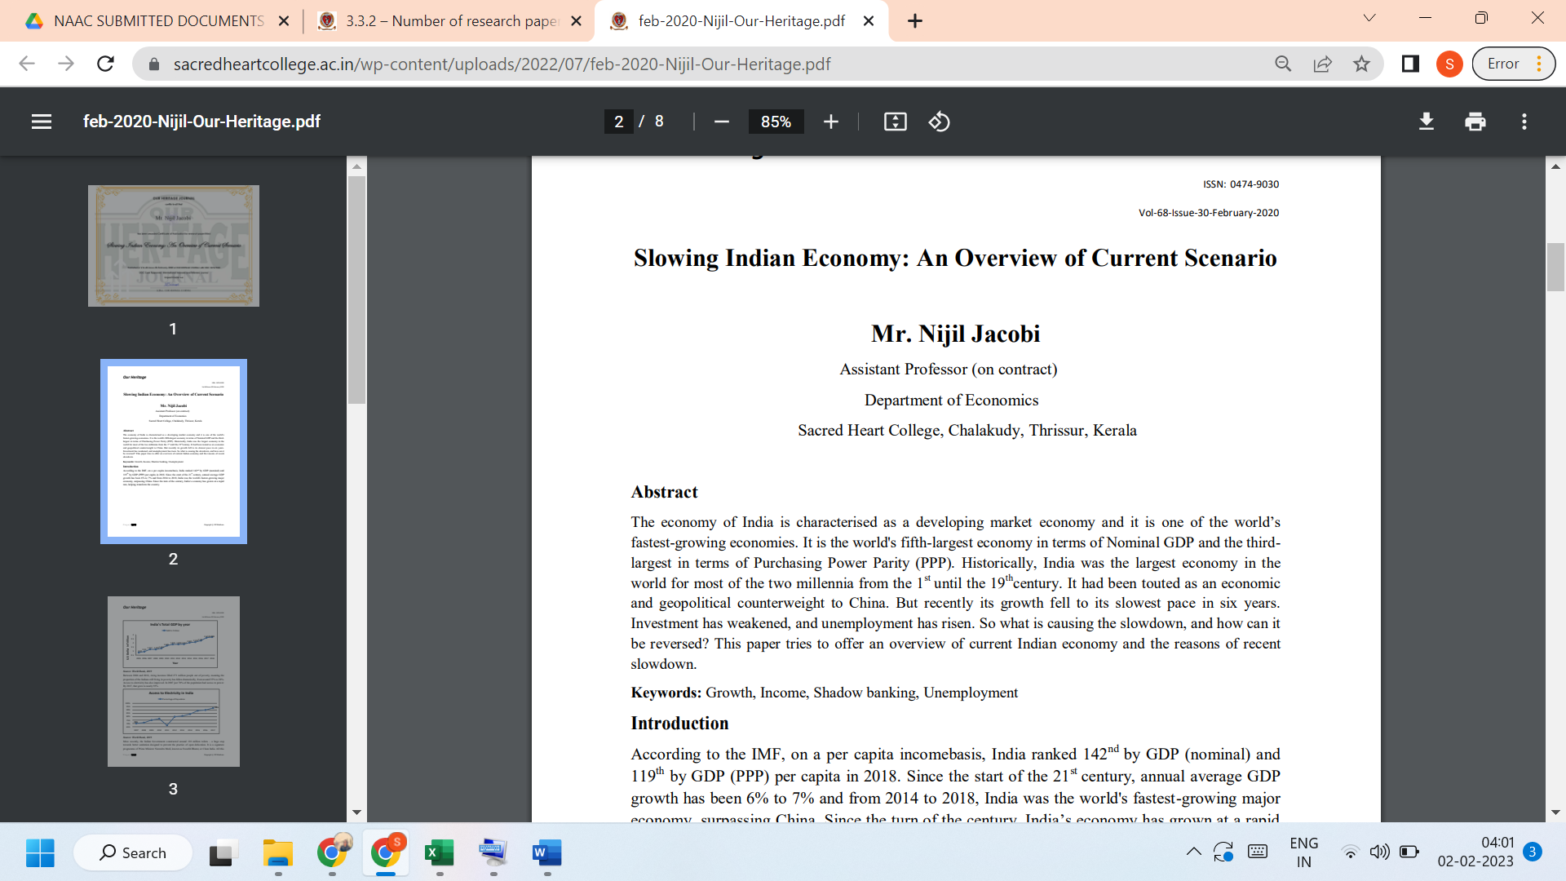
LINK TO THE ARTICLE:
https://archives.ourheritagejournal.com/index.php/oh/article/view/6995

