DIMENSIONS OF TRADE IN ENTERTAINMENT INDUSTRY WITH SPECIAL REFERENCE TO INDIA

BY DR. CHACKO JOSE P

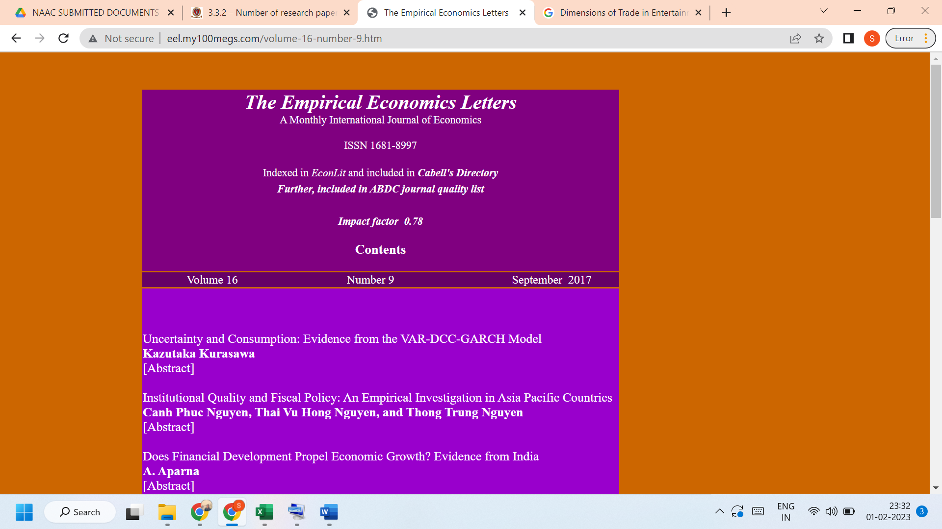

Link to the article:
http://www.eel.my100megs.com/volume-16-number-9.htm

