A HYBRID PRE-PROCESSING APPROACH FOR TEMPORAL ASSOCIATIVE RULE CLASSIFI CATION
BY DR. SR. MINI T.V

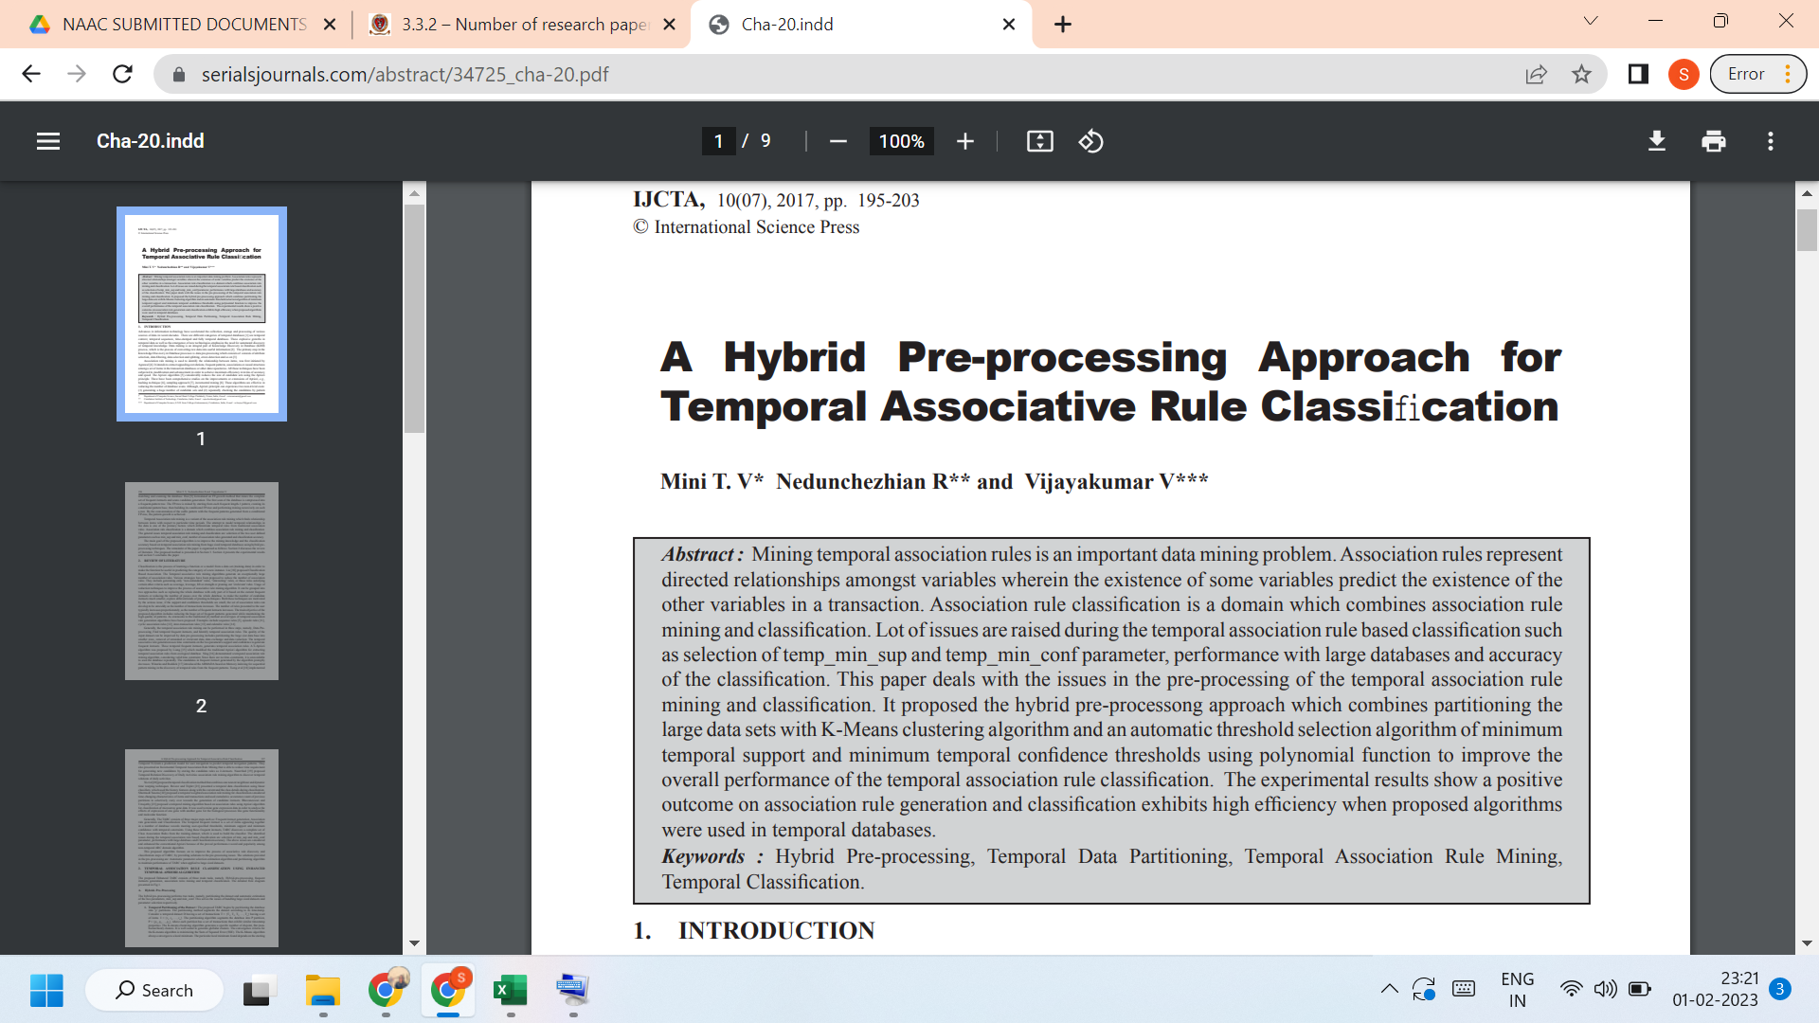
Link to the article:
https://serialsjournals.com/abstract/34725_cha-20.pdf

