EXPEDITION OF CORPORATE SOCIAL RESPONSIBILITY (CSR) DURING COVID-19 IN INDIA

BY NIJIL JACOBI

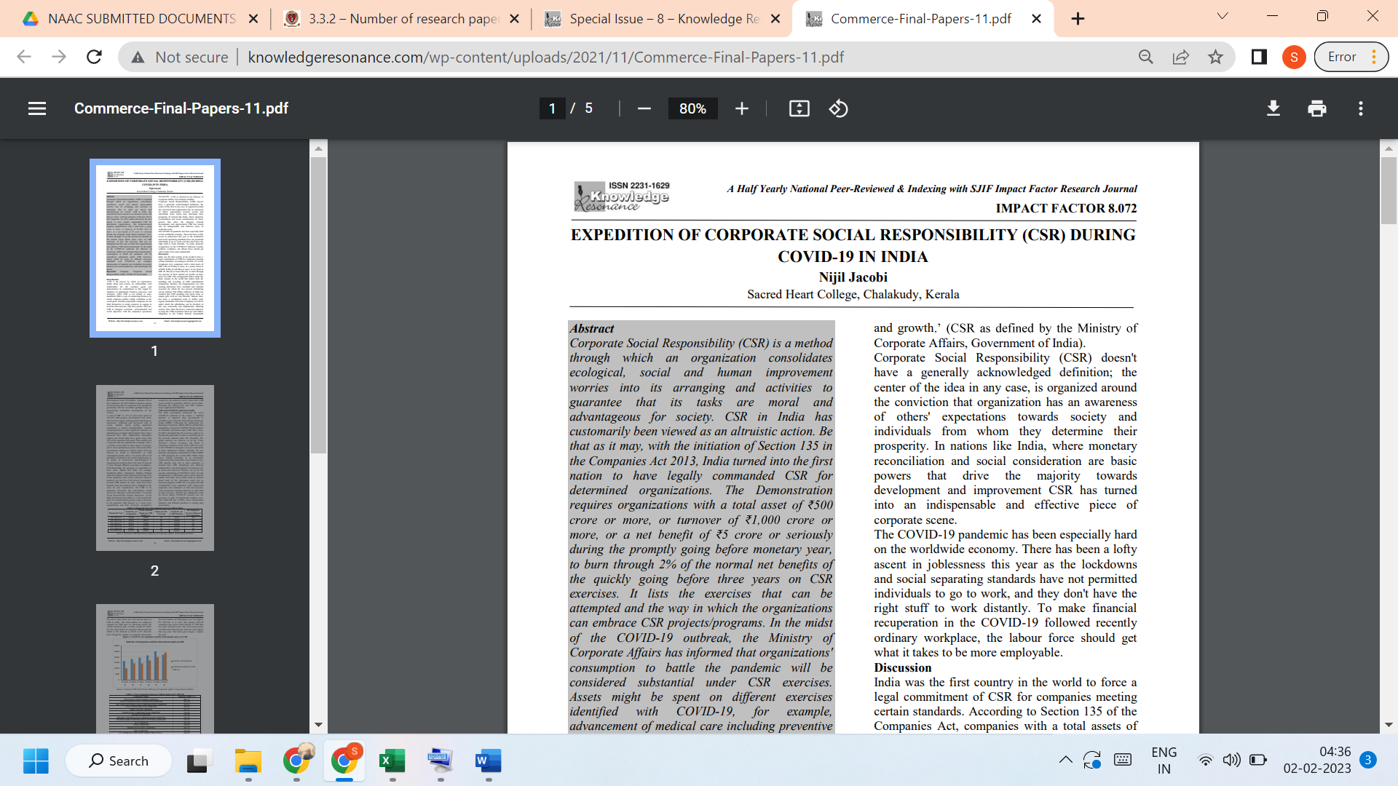
LINK TO THE ARTICLE:
http://knowledgeresonance.com/wp-content/uploads/2021/11/Commerce-Final-Papers-11.pdf

