LIFE-TABLE PARAMETERS OF SPIDER MITE TETRANYCHUS LUDENI ZACHER (ACARI: TETRANYCHIDAE) ON AMARANTHUS TRICOLOR L.

BY DR. SR. BETTY K P

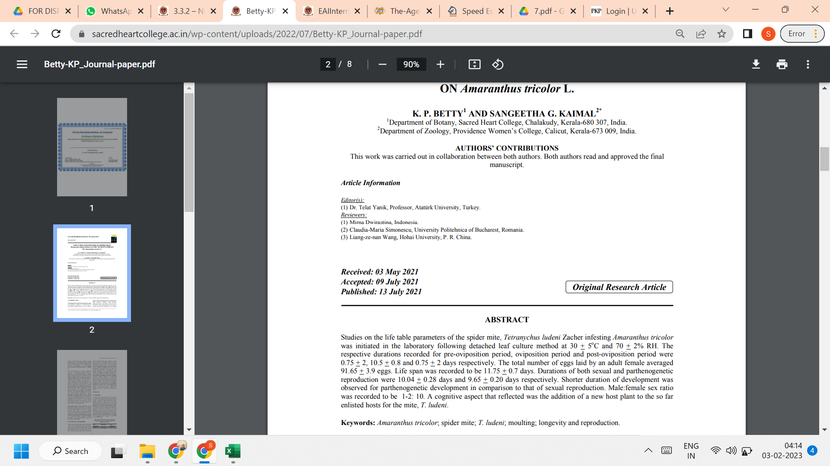

LINK TO THE ARTICLE:
https://mbimph.com/index.php/UPJOZ/article/view/2278

