INNOVATIONS IN DIGITAL TECHNOLOGY AND CREATIVE DESTRUCTION IN THE MUSIC INDUSTRY

BY DR. CHACKO JOSE P

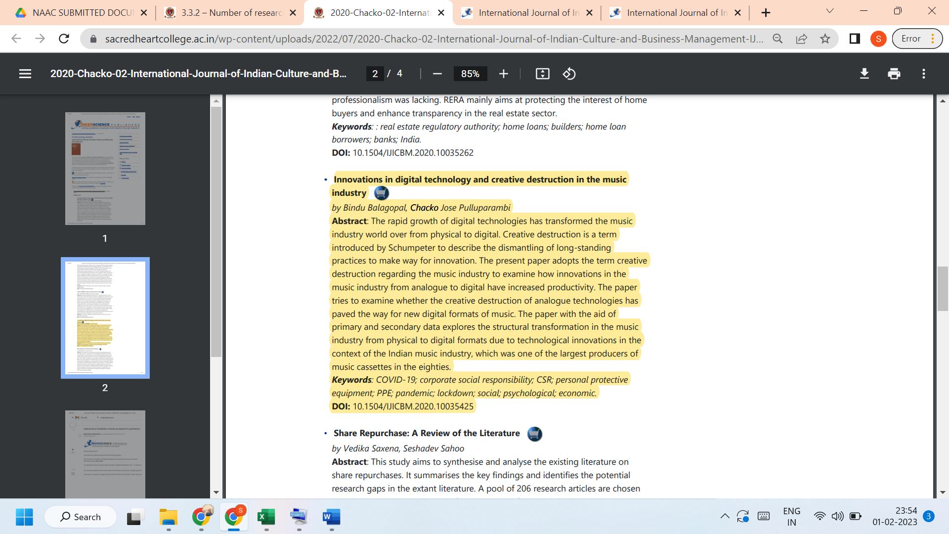
Link to the article:
https://www.inderscience.com/info/ingeneral/forthcoming.php?jcode=ijicbm

